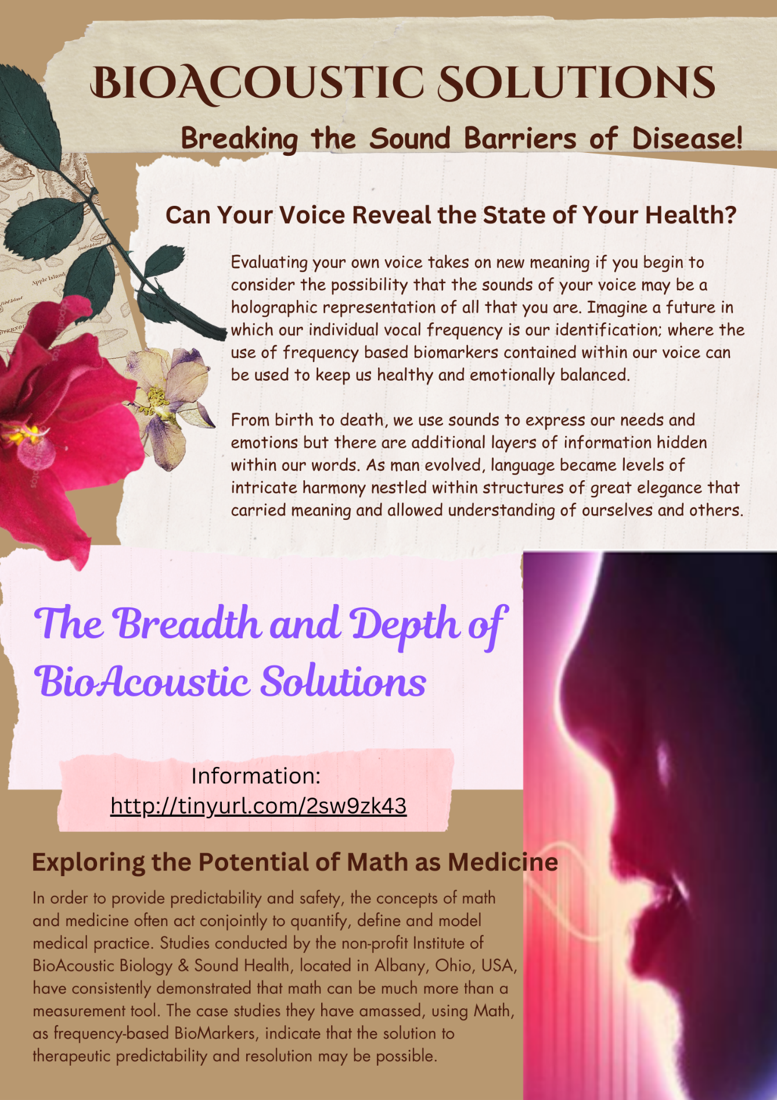
Compiled and edited by Jocelyn Davies and TJ Smith
Contents
Predictive Medicine 3
Parkinson's Disease and BioAcoustics 4
Reversal of Multiple Sclerosis (MS) eye damage 8
Decloaking Resistant Pathogens 8
Mommy, Why Do I Feel So Dumb? 10
Macular Degeneration 11
Sports Injury 12
The Kennedy Within 2019 13
9/11 14
Labor and Delivery 15
A doctor’s dilemma concerning Russ Rudy, MD 15
Jocelyn: A Fascinating Vaccine Story 16
REHABILITATION 16
Gout Relief via Sound Frequencies 19
Stroke Recovery 26
Confirmation with a look inside using Voice analysis 27
How important is the truth? 29
Online WorkStation created for Sound Health & Sound Healers 37
BIO – 40
Can Tiger’s Swing be Improved? 41

Why we must continue to break the sound barriers of disease
A proof-of-concept exposé

Suspend what you think is your reality for a moment. Suspend the fact that you think you have a physical body. What if your earthly presence is just a manifestation of an unseeable biofield?
Although we do not completely understand the origins of a perspective unseen body, it seems that such a biofield can be influenced by frequencies of light, aroma, color, sound, magnetics, electrical impulses, consciousness, or acupuncture meridians.
Birds, fish, whales, and insects use these unseen systems as a common part of their existence such as companionship and feeding. This ability allows animals, such as birds, sea turtles, fish, and even some mammals, to sense the Earth's magnetic field and use it as a natural compass for orientation and long-distance navigation, especially during migration.
So let’s imagine a world in which we can be individually identified, manipulated, and managed through the use of frequency-based biomarkers that can easily be identified through our individual vocal frequencies. What can we imagine?
Consider the brain as the central processing unit. Frequency-based signals are generated by the brain and have been determined to be a communication pathway traveling along our neural networks that self-monitors and keeps our bodies in stasis.
Since frequency can be represented in terms of mathematical equations, does this indicate that math could be the ultimate form of healing, and that math may be organic, or that we may just be sophisticated art forms that someone/something created?
Studies based on frequency-managed algorithms are well on the way to proving that at our core we may be very sophisticated math-based entities that can be “managed” through our individual frequency/energy-based Signatures.
Below is a broad listing that can be provided as a proof of concept for this idea:
Predictive Medicine – Comedian Robin Williams’ autopsy revealed the presence of Lewy proteins which are usually confirmed by a brain examination after death. Williams’ vocal print is just one example that verifies that Vocal frequencies can be used to determine the presence of unwanted brain proteins using only a 30- second vocal sample. This ability to predict menacing proteins in the brain before death, may, at a minimum, provide the opportunity to identify Lewy proteins (dementia-revealing frequencies) before actual symptoms occur. This would be an incredible advantage as increased numbers of people begin to suffer from various stages of dementia.
Prior to any autopsy reports Williams’ wife announced that he was suffering from Parkinson’s disease. A frequency-domain vocal graph, from over a year previous to his death revealed several spikes representing the Frequency Equivalent of Lewy Proteins: debilitating non-native brain deposits.
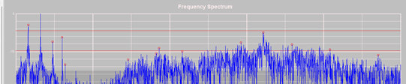
Robin Williams’ suicide provides information that will have consequences for millions of Americans facing debilitating dementia.

Parkinson's Disease and BioAcoustics
The pioneer of vocal profiling Sharry Edwards, and Dr. Apsley discuss underlying factors that may lead to Parkinson’s Disease and Cancer.
Sharry Edwards: One of the things Dr Apsley said, which sort of blew me away, was “ Sharry’s work defines and demonstrates the unifying field theory that defied Einstein”.
Marian Lewis, explains the issues she had from being exposed to radiation from her job at a nuclear energy plant:
Marian Lewis’ story:
Marians’ story began when she was eighteen. She was exposed to radioactive material while working at a Uranium processing plant in Southwestern Pennsylvania. This plant is now buried under twenty feet of earth with a barbed wire fence around it. At age twenty three she developed a low thyroid problem. At age thirty seven she had cancer in the saliva gland. She had radical surgery on the left side of her face that took her facial nerve. The left side of her face is paralyzed. When she turned fifty she had lung cancer. Then at seventy one she started a little trimmer that they later diagnosed as Parkinsons.
Sharry has a Q & A session with Marian Lewis. Marian, whom worked at a nuclear energy plant when she was eighteen discusses how, now at seventy one , she was on a “goodbye” trip to see her family for the last time because she felt she was dying from Parkinsons. Instead, after hearing Sharry Edwards on the radio, she decided to make a seven hundred mile trip to Albany Ohio, from Florida, to see if Sharry Edwards could help.
After meeting Sharry, Marian said “not only did it help me with my Parkinsons symptoms, but many other issues that I have.” On her first day of tone therapy, she started to feel tingling in numerous places of her body that had been numb for years. Then a few days later Marian stated “I went to the grocery store. Now the last time I had been to a grocery store, I couldn’t even make it around the store. I had to use a wheelchair. But, here I was walking around the store swinging my arms unassisted and smelling all sorts of things in the store. I saw a pile of cantaloupe and I decided to test it……I picked one up, put it to my nose and I could smell it, and honestly , I sobbed over the darn cantaloupe”. She was amazed at the progress she had made as a result of Sharrys tones and insight. Subsequently, in order to help others near her in Florida, Marian decided she wanted to become a BioAcoustic Practitioner or “BARA”.
What causes of Parkinsons disease have you now been able to identify?:
Sharry details two major enzymes. COMT, which degrades Catecholamines such as Dopamine, and Aromatic I-amino acid decarboxylase (AKA Tryptophan).
It has been found that people dealing with Parkinsons have a tremendous load of toxins in their body. Toxins that come from herbicides sprayed on crops, and GMO’s.
Sharry Edwards: There are three or four biggies being seen BioAcoustically.
Radiation poisoning: “robs the body of its electrical force so the body is in a constant state of stress in its attempt to get rid of free radical damage. It also breaks down the nervous system(another cause of PD). The sheathing surrounding the nerves does not get nourished and replenished. The cell signaling system becomes impaired and eventually breaks down.
How Bio-Frequencies work:
Sharry Edwards: You have a brain that is a central processing unit. All the signals from the brain go out to the rest of the body through your neural network. We just found a way to tap the system. If Marian, for example, is not getting signal to her toe, we can give her brain a signal that feeds her toe or gives her brain a signal that feeds the dopamine pathway and that addresses whatever is going on. We are tapping into the energy system of the body.
How can you find a local BioAcoustic Practitioner?
Sharry Edwards: You will find a map and a list of practitioners by clicking on the “Clinical Service” and the “Find a Practitioner” links on our website.
How can Bio-Frequencies help with detoxing heavy metals?
Sharry Edwards: We know what frequencies make the heavy metals give up their receptor site. You can do it with herbs, but you can also do it using Adenosine Triphosphate. That’s the first chemical made when conception takes place. It’s the same frequency as white light and it really takes care of the body in a very positive way. It also helps produce energy. It will bind heavy toxic metals including these radiation metals. You have to be really careful and watch for any kidney issues.
What can people do to get relief from their symptoms?
Sharry Edwards: Get away from Aspartame, MSG, Gluten and avoid eating GMO (genetically modified) products. There’s an article about GMOs and cell signaling, and how that’s related to Parkinsons. The article is on our website under “research articles.”
What do the tones sound like?
Marian Lewis: They are very low sounds. It sounds something like the fan or refrigerator running in the background.
Sharry Edwards: The tones emulate the frequencies of your brain. Your brain speaks math: 0-64 cycles a second. If we want to talk to your brain, then we are going to need to speak math because that is the language your brain speaks, math can be defined using frequency.
Marian Lewis: If you cup your hands over your ears, you can hear the sounds of your body.
Sharry Edwards: That sound is a form of feedback called an Oto-Acoustic emission that is a perfect sound for you all the time. It’s a feedback loop of how your body is supposed to heal itself. We get into this in class. All this ancient stuff, and how to teach people to do it for themselves. That is what we really like to do. Teach everybody to do this for themselves.
How could Bio-Frequencies do anything for a person with a Gene that’s Defective?
Sharry Edwards: We can help a person shut off or turn on a gene. The way Dr. Apsley became familiar with my work is that he was working with a little girl named April that had Downs Syndrome. She came here with her mother. April's symptoms: The face, the large forehead, the slanted eyes, clubbed looking fingers. All of it disappeared because we were able to shut down the gene.
Here is what happens to the body. I'm not making this up. This comes from Dr. Robert O. Becker. When the body gets traumatized, hurt, or cut, the cells send out a “rescue me” signal that calls Calcium to the site. When there is no Calcium, there is a cancer food in the body that is 1/100th different from the frequency of Calcium. If there is no Calcium in the system, it is our theory that the body calls this frequency to it which happens to be food for cancer.
Is there a connection between Tetanus inoculations and Parkinson’s symptoms?
Sharry Edwards: Absolutely. Especially if you have problems with the little toe side of the foot. There is either pain there or that side of the foot is curling under. If this is the case, then it is usually the live virus that is causing it. And lockjaw, it looks like Parkinson’s. People experience the feeling of muscle freeze a lot. They try to take a step and the muscles just wont behave. They wont go where they ought to go. It is really Tetanus and they’re not willing to admit that there are vaccination relationships that are going on with Parkinson’s symptoms. Marian had that in her chart and some of her toes were turning under. We had to give her the antidote for the Tetanus shot.
How to hear Marian Lewis and Sharry Edwards of Parkinson’s radio:
Visit www.blogtalkradio.com/parkinsons-recovery and scroll back to find the show that aired August 31st 2011 featuring Sharry Edwards and Marian Lewis as my guest.
Reference:
This article was abridged from the book “Pioneers of Recovery-Stories of Nine Pioneers who Reversed the Symptoms of Parkinson’s Disease” written by Robert Rodgers, Ph.D.- Parkinson’s Recovery. Pages 94-122.

Reversal of Multiple Sclerosis (MS) eye damage
“Gelene has a history of Optic Neuritis in her right eye and has had color vision abnormalities in the past. Today her color vision is normal. I can’t even tell which eye had the optic neuritis without close examination within the eye to view the atrophy which is minimal now.” – Julie Lew, MD

“The color vision test went from 2 out of 14 to 14 out of 14.” – Dr. Lew’s Physician Assistant

In the United States, it is estimated that over 1 million people are living with multiple sclerosis (MS). Given that up to 80% of people with MS experience some form of eye-related issue during the course of the disease, this means that approximately 800,000 individuals with MS in the U.S. may face vision problems at some point. This could likely be prevented.

Decloaking Resistant Pathogens
In 2000, Nexus Magazine published a preliminary study that had showed that resistant pathogens could be decloaked using frequency oscillations. In December 2019, the same protocol was to examine the frequencies of Covid. Published information showed that this virus was likely synthetic. Their “synthetic” proclamation and frequency-based antidotes were shared in five additional articles. How many people died? How much profit was made in the name of a supposed pandemic?
Based on these findings, we created a template that could be used by the public to BioAcoustically evaluate their own vocal frequencies for these issues: Services/Campaigns at https://www.soundhealthportal.com/. The idea of putting health into the hands of the people, establishing SELF-HEALTH has always been paramount to the mission of the Sound Health Institute.

Toxicity Identification–

Toxin represented by high hollow peak.
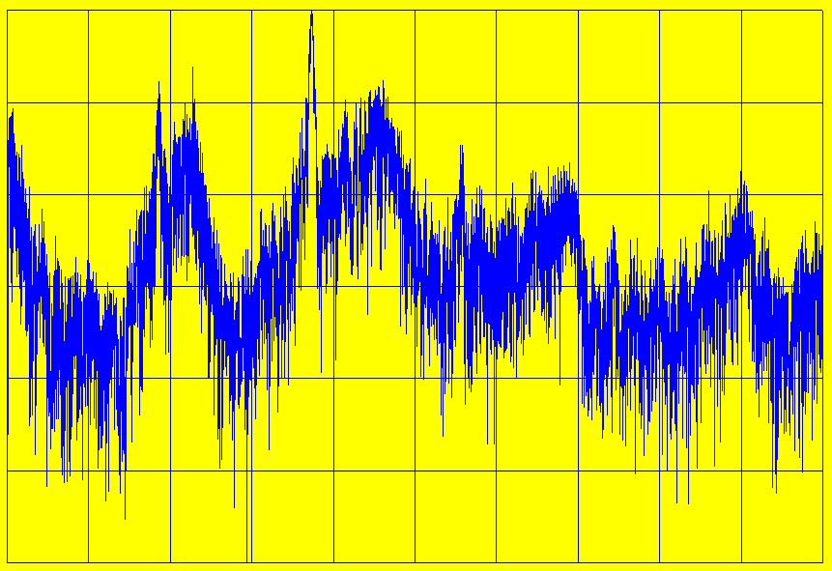

This was a short study based on individual reactions to aspartame.

Environmental Poisoning of a child explained by her mother, Ronna


Mommy, Why Do I Feel So Dumb?
They said she had forgotten how to read! Over the summer, Andi, a top reader last session, had forgotten how to read. I couldn't believe it.
I met with her teacher, and it was decided that Andi should be put in a special reading class. Andi was embarrassed and reluctant to go to school. She cried every day. On the days she didn't cry she pretended to be sick. My heart ached for her. The special classes were not helping. I didn't know what to do.
One day while we were riding in the car, Andi wrote something on a small slip of paper and handed it to me. Her head was down. She was staring at her lap. It read, "Mommy, I feel so stupid. Why can't I read anymore?" My tears were so quick and so thick that I pulled over onto the side of the road. We cried together, embracing, sharing the frustration and dismay. Was I such a failure as a parent that I could not find help for my child? I vowed to find an answer for Andi and for myself.
I was aware of a pioneering technique that used low-frequency sound to help another little girl in our area reverse mental retardation. I scheduled an appointment. During that session, using low-frequency sound, Andi was able to read clearly and without hesitation. Her relief and my joy were indescribable.
The test pointed to the possibility that Andi had been poisoned with formaldehyde, a chemical preservative. Frequency-based antidotes were provided and Andi's self-esteem soared. I had a bright, cheerful, intelligent seven-year-old again.
We had the other two children tested. Both of them had been affected but not to such an extreme. As they all entered the program, behavior problems decreased and there were considerably less arguments in our home.
What would have been the consequences for my child? Her life would have been charged with unfair opinions and gossip that she did not deserve.

Macular Degeneration
Macular degeneration, commonly referred to as age-related macular degeneration or AMD, is a condition in which the macula, the part of the retina responsible for detailed and central vision, deteriorates causing vision loss. The conventional medical literature states that there is no cure for AMD. According to a study published in Archives of Ophthalmology in 2004, an estimated 1.75 million US residents endure this condition, and due to an increase in the elderly among the population, it is estimated that by the year 2020 that statistic will rise to 3 million.
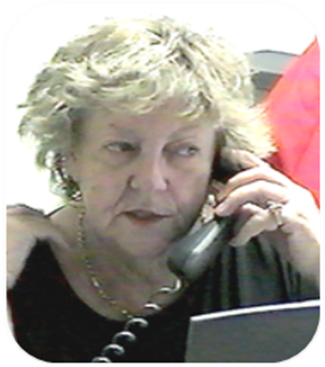
Pauline Ward has been a participant with Sound Health for 14 years since being diagnosed with dry macular degeneration almost seven years ago while in her early sixties.
According to Pauline, her optometrist was the first to detect the granules in her eyes, though it took six/seven years before the condition actually affected her vision. Her blind spot grew until about three years ago when its scope spanned the proportion of a quarter, which is visually the range of seventeen characters on a page of print.
Pauline travelled from Australia, where there were no methods of treatment, to the US to try the revolutionary technique of BioAcoustics. After about 10-11 seconds with the appropriate frequency, she could see haze through the spot, though not clearly. After several days of tones, she was able to see complete letters within the holes and eventually the span of her impairment decreased as did holes in her vision. She even regained the ability to see rich colors myopically.
Pauline responded “…it wasn’t the first sound you tried, or the second or the third; you know it might have been the tenth. So I’m sitting here thinking, ‘Oh nothing’s happening, nothing’s happening, nothing’s happening’; so I wasn’t expecting it, you know, because you think nothing’s happening and then suddenly the right sound (for) ten seconds and it’s amazing. You can begin to see the letters and colors.”
In the United States, age-related macular degeneration (AMD) is a leading cause of vision loss, particularly among older adults. According to estimates from the American Academy of Ophthalmology and the Centers for Disease Control and Prevention (CDC):
BioAcoustically Speaking, it is the rectus eye muscle frequencies that are involved in all cases of macular degeneration seen at the Sound Health Institute.

Sports Injury
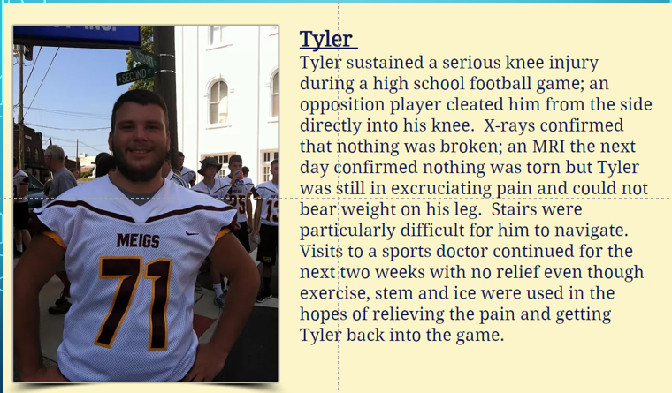
The evaluation of Tyler’s vocal frequencies took about 30 minutes and indicated that Tyler had two thigh muscles in stress. Ambient sound was presented to him for about a minute; his parents were elated and amazed when he reported that his pain was diminishing. “He was just standing there, listening. How could a sound decrease his pain?” questioned his mother.

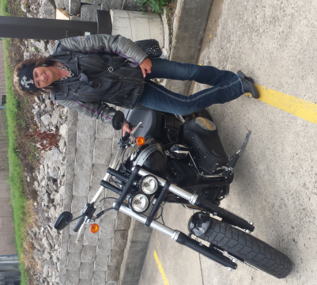
Kelly
Kelly stoically hobbled to work where she reported her pain to be a 5-6 on a scale of 1-10. She was immediately sent to the Sound Health lab where she was provided a sound known to alleviate bone pain. Within minutes her pain was gone and there was no limp; all swelling dissipated. Within a few days Kelly was able to wear her boots and bend her toe with no pain. Her doctors reported that her broken toe and related foot injury healed in record time; one of them wants to know more.

Jen
A fall down the front steps resulted in a fractured wrist and a deep muscle contusion for Jen.
The Sound Health Research Institute was nearby and offered to look at the trauma through Vocal Analysis protocols. In Jen’s own words, “A sound was presented for my thumb, which relieved the thumb pain. My wrist was also hurting. The wrist sounds caused my wrist to quit hurting, but my thumb began to hurt again. A Tonebox was set for both tones and I continued to listen to them.
Sound Health personnel urged me to go to Urgent Care just to make sure my wrist and/or finger were intact even though the pain was minimal. The nurse was surprised that I had no pain considering that my bone was fractured, she thought I ought to be in more pain. She asked if I had taken any pain meds before I came in. I explained that the only thing I had taken was some sound. That likely sounded a bit strange to her, but she was impressed, and she wanted to look into sound therapy a bit further.

The Kennedy Within 2019
A request came to the Institute that requested a BioAcoustic evaluation of the vocal frequencies of Robert Kennedy Jr. to possibly identify a cause for his stressed speech. BioAcoustic analysis sees the voice as a holographic representation of the brain. The recurrent laryngeal nerve is responsible for voice box function and has a direct connection to the brain. At that time, Kennedy’s vocal print revealed that the frequencies associated with acetylcholinesterase, an enzyme that catalyzes the breakdown of Acetylcholine that functions as a neurotransmitter was stressed.
2019 interviews of Kennedy reported that, he “appeared to exhibit symptoms of spasmodic dysphonia, described as a “neurological disorder that causes involuntary spasms of the larynx.”
The genetic inefficiency of Acetylcholinesterase can cause a multitude of issues associated with the use of Choline. Inositol, a companion to choline, was also BioAcoustically low for him at that time.
The frequencies associated with the cricoarytenoid posterior muscle appeared to be weak in the 2019 evaluation. This muscle opens the vocal cords and is also involved in breathing.
The biochemical information gleaned from his first BioAcoustic vocal map was impressive, but it was also intriguing what his voice revealed in his Personality Profile. His voice matrix was remarkably similar to that of Ron Paul, a Texas Congressman and presidential candidate in 2008. Ron Paul’s was the most honest vocal print we had ever reviewed. Since his thwarted run for President, Libertarian Ron Paul has remained a determined patriot in support of the rights of the people.
Kennedy’s voice in 2019 and now (2024) show similar qualities with accomplishment being primary, emotions secondary with intellect as a strong foundation. He is a multi-tasker and balanced thinker, capable of considering all information needed to come to a knowledgeable conclusion. He shows prejudice for balanced information, but he does not believe that is happening in our country today (His current words are supported by his vocal print).
Kennedy’s main concern is intelligent, nonpartisan management of physical priorities. He adroitly uses facts to support his claims. His self-emotions are resilient, and I believe he is willing and emotionally capable of taking on the task of bringing America back to a state of freedom and equal Justice. His perspective concerning justice is not guided by personal needs but by equal justice for everyone. He will be supportive of the history of America as a bastion of freedom equally and wholly distributed to all those who deserve protection under the founding principles of democracy.

9/11
The staff of Sound Health was invited to evaluate several scientists working in the gaping hole left by the terrorist bombings of 9/11. Based on those preliminary findings they were invited to the Firemen’s Union Headquarters in New York to evaluate 17 additional firefighters who were experiencing the “Fireman’s Cough.” Most had been exposed to Mirex. It was demonstrated on-site in the Union Hall that frequency presentation could stop the fireman’s cough. We were invited by the Union President to test all 1700 exposed firefighters. The next day we were disinvited by his legal advisors. How much suffering could have been prevented?

Labor and Delivery
A BioInformatic paper was delivered at a Ohio University Conference showing that the biochemical, Pitocin (which artificially initiates labor) could be monitored using voice frequencies. An expectant mother went into the hospital for a planned birth but ended up having a C-section. We started monitoring her voice at 5:30 am and by 10:30, her voice indicated that her body was fighting the drug. She stayed in labor until 3 the next morning when both she and the baby went into stress – an emergency C-section was performed.
Think of how many trips to the hospital – only to be told it was false labor – could be prevented! Set up properly, a phone call to the hospital could be evaluated instantly.
Longer Pitocin article link: https://tinyurl.com/3xtk7jmy

A doctor’s dilemma concerning Russ Rudy, MD
At a recent international medical conference (A4M) a BioAcoustic case study concerning Russ Rudy, MD, was presented. Rudy had been diagnosed with Multiple Sclerosis (MS), resulting in serious leg muscle atrophy and neuropathy. He was informed that his situation was dire, incurable and nothing more medically could be done for him; he was sent home to die with a Baclofen pump internally installed to help control the pain.
Instead of accepting the death sentence, Dr. Rudy visited the Institute of BioAcoustic Biology & Sound Health in Albany, Ohio where voice analysis has been explored since 1984 as a diagnostic tool for past, present and future health issues.
A computerized evaluation of Rudy’s vocal frequencies identified math-based biomarkers which indicated spinal damage architectures within his vocal sounds, and further indicated that no MS markers were present.
Over the next few months, lab reports confirmed that nerve recruitment was taking place from Rudy’s waist to his toes. This is totally impossible by standard medical practice. The Baclofen pump was removed (usually done at autopsy), his legs now supported him, and he no longer needed a scooter to move about.
Rudy was able to return to his medical practice as an emergency room physician. To this day, he believes that his erroneous MS diagnosis would have condemned him to a shortened, inferior quality of life. He is incredibly happy that using the frequencies of his voice as a guide, the computer was able to reveal the definitive mathematical cause for his lack of wellness.

Jocelyn: A Fascinating Vaccine Story
Twenty-six years ago a young three-year-old named Jocelyn, who had been diagnosed with hyperlexia, was brought to our Sound Health Clinic in Ohio. We were told that Jocelyn would only repeat sentences of others to convey what she wanted to express but would not create her own sentences.
Jocelyn’s parents claimed that she could also read well beyond her age.
I was skeptical, so I put a Wall Street Journal in front of her. She read several sentences correctly. The computerized evaluation indicated that she had a negative reaction to the frequencies associated with a mandated vaccine known as DPT.
When she was ambiently presented with an antidoting frequency formulation, she turned to her father - she was sitting on his lap holding her doll – and said to him, “This is a dolly.” We were all flabbergasted.
We created a tonebox layered with frequencies for her based on her voice architecture. She quickly began to initiate appropriate vocal interactions. Using the information of her case and many others, we were able to create a database template – called PreVac - of frequencies associated with vaccine damage.

REHABILITATION
In 1993, Bob Bethel, an attorney, survived a serious motorcycle accident that left his lower right leg severely damaged. Several major surgeries and hours of reconstructive surgery were required to create the illusion that his leg muscles were intact. Bethel’s physicians had little hope for a complete recovery and told him to consider himself lucky to be alive.
Bethel moved back home to Ohio to recuperate. He had little hope that he would ever be able to practice law again and still less hope that his passion for tennis would be a part of his future. At a local grocery store, he bumped into a fellow tennis player. During this brief encounter, Bethel learned that a local company, Sound Health Alternatives, was conducting experimental research to evaluate the idea that low-frequency sound could be used to help regain muscle strength and control.
“I’m a lawyer and an engineer, so I was skeptical,” Bethel said, but he had little to lose and nothing else had helped, so he decided to give it a try.
Today, Bethel is no longer a skeptic. “The swelling is gone. There is almost no pain. I had severe limping and could not run at all. Now I can run,” states Bethel in a very matter of fact manner. “As we continue to work, I can move more, and I’m now matching Bill (the person he met in the grocery store) on the court step for step...something I never thought I would be able to do.”
See Bob’s story in the documentary, Miracles of Non-Medicine – https://vimeo.com/126935179
“Although we can work independently, we prefer to provide pre-management diagnostics to health and medical practitioners,” Edwards said.
Work in this field, dubbed “BioAcoustics” by Edwards, is most closely akin to biofeedback and is just now being perceived as a complement to preventive health practices. Three courses in BioAcoustics are offered online for a certificate program. Edwards has presented dozens of papers to conferences across the country concerning her research and findings. She and Dr. Terrence Bugno presented a paper to the International Conference of Energy Medicine.
“BioAcoustics has a place in health care. We can assess clients, confer with their health care practitioners, and suggest programs of intervention. We provide insight into what may be happening with a person. We offer the opportunity to look at the body as a whole. Many times we can see directions that haven’t ever been considered,” Edwards said.
For people like Bethel, it is a miracle. He has his life back. Something he thought would never happen, once a skeptic, he now admits that BioAcoustics may be the medicine of the future.
“Sonic Apothecary,” a video about BioAcoustics produced by Healing Vision Films, Inc., is available at area libraries for anyone interested in learning more about Sound Health technology.
This article was reprinted from the article that appeared in the Community section of the Athens Messenger on Monday, Sept. 13, 1999.

Jesse – trauma – rehab - 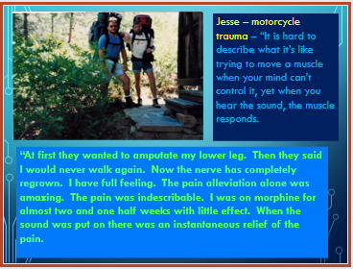
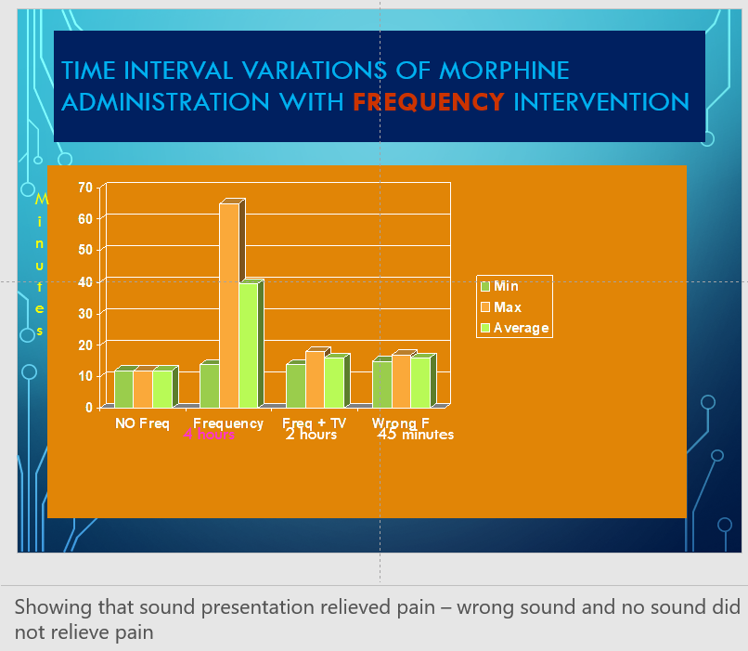
In the U.S., the annual cost of motor vehicle trauma rehabilitation is significant. In 2019 alone, motor vehicle crashes cost society $340 billion, covering medical expenses, lost productivity, legal costs, and emergency services. The total societal harm, factoring in quality-of-life impacts, was estimated at nearly $1.4 trillion ​(NHTSA). Additionally, the total cost of motor vehicle injuries in 2022 was approximately $481.2 billion, reflecting expenses related to medical consultations, rehabilitation, and more​ (Injury Facts). These figures highlight the massive economic burden associated with trauma care from vehicular accidents each year.

Gout Relief via Sound Frequencies
Dr. Murphy was participating in a BioAcoustic Vocal Profiling Training for medical professionals in which the class was evaluating the potential of pain relief using low-frequency sound. Being both skeptical and curious, Dr. Murphy inquired if there was a sound that would eliminate gout pain. His big toe often swelled, turned red and was very painful if he ingested certain foods or drink. Imbibing Whisky caused the most pain for him.
The class decided to set up an experiment as a group intervention. Sure enough, the sound frequency combination that had been identified the year before, not only relieved the pain almost instantly but began to obviously decrease the redness and swelling.
The event was recorded, and we are making the 2002 class video available to the public to show that Dr. Murphy was incredibly pleased that the sounds successfully relieved his discomfort. Link: A Perspective on G-OUT - https://tinyurl.com/62mdvjr6

Background from AI about Gout
“Gout, a form of inflammatory arthritis characterized by sudden and severe pain, swelling, and redness in the joints, has long been a source of discomfort and debilitation for those affected. Approximately 9.2 million people in the US experience gout pain flare-ups.
Traditionally managed through dietary modifications, medication, and lifestyle changes, recent advancements in health technology are exploring new ways to detect and manage gout that does not include debilitating gastrointestinal side effects. Online sources report that one such advancement is the emerging field of vocal biomarkers, a promising area that leverages voice analysis to diagnose and monitor health conditions. This innovative approach could provide new insights into gout and offer alternative pathways of pain relief.”

Understanding Gout: Causes and Symptoms
Gout is caused by an excess of uric acid in the blood, leading to the formation of sharp, needlelike crystals in the joints. This often results in intense pain, typically affecting the big toe but also other joints such as the lower back, ankles, knees, wrists, and fingers. The condition is often associated with a diet high in purines (found in red meat, shellfish, alcohol, and sugary drinks), hypertension, obesity, genetic mutations, kidney disease, other medical conditions, and certain medications. Recent studies have associated uric acid with diabetic joint pain. Gout frequencies can usually relieve such pain.
The symptoms of gout can be unpredictable, with flare-ups occurring suddenly, often without warning.
The pain can be excruciating, accompanied by swelling, warmth, and redness in the affected joints. Over time, recurring gout attacks can lead to chronic joint damage and other health complications.
Vocal Biomarkers: A New Frontier in Health Diagnostics – from online AI information.
“Vocal biomarkers have presented an innovative approach to health diagnostics, where the analysis of voice patterns can reveal underlying health conditions. Pioneered by researchers like Sharry Edwards, this field is based on the premise that the human voice reflects the body’s internal state. By analyzing the frequencies and patterns within a person’s voice, it is possible to detect imbalances and identify potential health issues.
In the context of gout, vocal biomarkers could provide a non-invasive method to monitor the condition. For example, changes in vocal frequencies might indicate an impending flare-up or provide insights into the body’s inflammatory state. This could allow for early intervention, helping to prevent or mitigate the severity of gout attacks.”
The Institute for BioAcoustic Biology & Sound Health has reported that their record for the relief of gout pain using specific low frequency sound presentation is often less than a minute.

The Connection Between Vocal Biomarkers and Gout
“The relationship between vocal biomarkers and gout lies in the body’s biochemical processes.
Gout is linked to metabolic disturbances, particularly the overproduction or underexcretion of uric acid. These metabolic processes are reflected in the body’s frequency patterns, which can be detected in the voice.
By analyzing these patterns, vocal biomarker technology could potentially identify signs of metabolic imbalance before they manifest as a gout attack. For instance, specific frequency disruptions in the voice might correlate with elevated uric acid levels or inflammation. This information could be used to adjust treatment plans, dietary recommendations, or lifestyle changes to prevent flare-ups.”
Moreover, vocal biomarkers could also be used to monitor the effectiveness of gout treatments.
By tracking changes in voice patterns over time, healthcare providers might gain insights into how well a patient is responding to medication or other interventions. This could lead to more personalized and effective treatment strategies, reducing the frequency and severity of gout attacks.

CONCLUSION: The Future of Gout Management
Gout remains a challenging condition to manage, with flare-ups causing significant pain and discomfort. However, the advent of vocal biomarkers and the exploration of sound therapy offer new avenues for diagnosis and treatment. By leveraging the power of sound and voice, these innovative approaches could revolutionize the way we understand and manage gout, providing patients with more personalized, effective, and holistic care.
As the science behind vocal biomarkers and sound therapy advances, we may one day see these techniques integrated into mainstream healthcare, offering a new standard of care for gout and other metabolic disorders. Until then, the intersection of vocal biomarkers, sound therapy, and traditional gout treatments represents a promising area of exploration for those seeking alternative and complementary approaches to healing.
REFERENCE
Gout Facts and Statistics: What You Need to Know link: https://www.verywellhealth.com/gout-6273971

BioAcoustic SUMMARY - November 2024:
BioAcoustic Frequencies active for the month of Nov 2024 – these frequencies are cyclical each year depending on what frequencies are bombarding the earth. Keplar and Pythagoras both tried to explain the phenomenon of Orbital Resonances. Kepler reported that the frequencies of the movements of the planets are heard by our soul and establish our health equilibrium and personality traits.
Inner planetary frequency influences for the month of November 2024
Oct – Nov 4
The joints and muscles seem to be under attack for the next few days, especially the back and hips. Deep hip muscles that support walking mobility and the upper back muscles are particularly vulnerable; the Gluteus Medius and Trapezius respectively are involved.
Also in stress for the next few days: Chondroitin sulfate which supports flexibility in the muscles and Hyaluronic acid that supports joint health and elasticity. Perhaps our flexibility is being challenged as we prepare to Vote on Tuesday.
Calcium is an important nutrient in support of Vitamin D which begins to wane for those in the northern hemispheres as our blood begins to prepare for winter. Fibrinogen is an important factor for blood circulation and blood flow. Maybe some extra caution is needed as the days/nights get colder.
CAUTION: The internet is full of advice on losing weight. One of those suggestions is to sleep in a cold room to increase fat burning. This may not be a good idea for people who have blood viscosity issues.
Elastase fits well into this mix of frequencies for the next week. Although Elastase is not a much talked about enzyme, its purpose is to break down proteins particularly elastin which together with collagen supports connective tissues. Elastase also helps break down the proteins of incoming invaders that are so prevalent in the colder months.
Immunoglobulin E (IgE) is now in play. IgE is responsible to support immunity against parasites, which happen to be Staphylococcus for the next few days. Asthma, sinus, and food sensitivities may be more prevalent in the coming week while IgE is active.
Calcium Ascorbate (orange juice) has the dual responsibility of supporting the immune system while being a vital support for collagen and connective tissue.

Nov 5-11
Genetic frequencies for Psoriasis (dry, red skin condition) are upon us and have been with us for many days now. If people wonder, why they are having flare-ups, it may be the frequencies coming to earth from our solar system. You could consider food sensitivities but this time it is likely not your fault.
B12 co factors are associated with the skin and are also on the rise in the next few days so you might want to ingest a few more B12 foods. (Fish, meat poultry, eggs, milk, milk products, cheese and some breakfast cereals are fortified artificially with B12. Yeast has been reported as a good vegetarian source. You don’t need much B12 but it is essential for energy, blood formation and cell division.)
The virus for the Common Cold is sneaking up on us and in keeping with Mother Nature’s wisdom, ascorbic acid (part of Vitamin C known to strengthen the immune system) is active as well.
For those suffering from muscle stiffness and strength issues, Dopa, the precursor for Dopamine will come in play on Monday next. Dopa is part of a cascade that produces the neurotransmitter of Dopamine, Serotonin and norepinephrine; all of which are involved with appetite and weight control.
Muscles coming into stress include the Levator Scapulae (shoulder arm), the hamstrings (back of the thigh), the Quadratus Lumborum (lower back) and the Tensor Fasciae Latae (hip).
We have created a template for Hives. It is available for use on our online WorkStation - www.SoundHealthPortal.com
EBV (Epstein Barr virus), Cholesterol, myostatin, niacin, caffeine and magnesium stress combine to cause feelings of fatigue for the next few weeks.
Joint pain – especially in the knees kick in this week – inflammation of and lack of joint fluid is the culprit. Too much fibrin can also contribute to joint pain. If you test your voice, you will find that the notes of F-G are too high. You can ask for a free nutrition evaluation at SoundHealthPortal.com.
Thyroid stress continues for the next two weeks. Iodine, selenium, and zinc are all thyroid supporting nutrients. The internet lists food that are problematic to thyroid function. Selenomethionine may be supportive –it can be found at your local health food store.
Niacin (vitamin B3) is especially important to brain function this week.
Expect shoulder girdle muscles to start to flare.
Genes for colon cancer and diabetes come into play for the next few weeks.

Nov 12-18
Knee muscles continue to flare and begin to involve thigh muscles. Muscle evaluations are available from SoundHealthPortal.com – under CAMPAIGNS.
Nutrients in stress SAMe, vitamin D4, 25-hydroxycholecalciferol, calcifediol and Vitamin E.
Nanobacteria come into stress this week and can cause tooth plaque and heart sac inflammation. Heart Muscle is stressed this week.
Thyroid stress continues, especially for those using thyroid medications.
Stress involving proteins are active now and may cause gout symptoms (sharp joint pain).
Shoulder muscles continue to aggravate, involving Rhomboid, trapezius and chest wall that helps support shoulder movement.
Diabetes frequencies continue to soar; those with fatty livers will be especially vulnerable using a high-carb diet.
Muscle atrophy, both genetic and those caused by statins and aging, continue to plague, especially the elderly. You may find your muscles seem weak for the next few weeks.
Candida may be more active toward the end of the week. Sugar overload may cause an inflammatory flareup.

Nov 19--25
The stress of iron is obvious for this week. Spine issues associated with Lumbar 5 (lower limb circulation, Prostate, sciatic nerve and Thoracic 4, gall bladder, liver) may become active.
Shoulder and hip joints continue to need detoxification to relieve Glymph system fluid (waste clearance). Nitric Oxide – found in beets - may be of assistance.
The pancreas starts a fortnight of stress this week.
Staphylococcus aureus found as a cause of upper respiratory and skin issues comes into play on Wednesday.
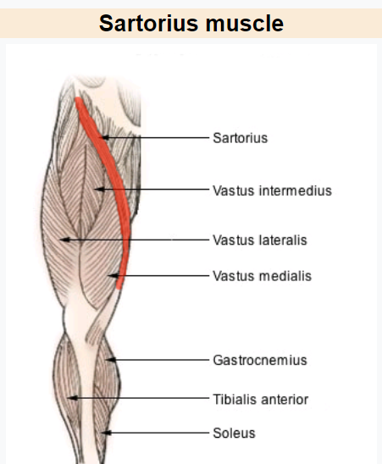
Nutrient in stress – l-Carnitine, which supports energy metabolism of the mitochondria. Carnitine concentrates in cardiac and skeletal muscles.
The Sartorius Muscle begins to activate near the weekend. The Sartorius is a strap-like muscle from the upper outer thigh to the inside of the knee that supports the hips and knees.

Nov 26 – Dec 2
The Liver starts to stress via the gallbladder and bile salts – particularly cholic acid, which is synthesized from cholesterol – Co-Enzyme A is involved – may be Statin related.
Myopathy genes continue to activate. HMB (Hydroxy β-methyl butyric acid) may be useful. It is used to prevent muscle wasting and is available as a dietary supplement.
Thigh muscles and upper jaw will need extra care and stretching. You may want to consider a massage or facial.
Glutamate and glycine receptors and stressed this week. Aspartame MSG toxicity may be more noticeable.
Frequencies to eliminate the stress of gout pain almost immediately are available to the public. No one should be made to suffer gout pain any longer. There are over 6 million people worldwide who report gout pain. Many specialty toneboxes including G-Out can be found here: bioacousticsolutions.net/store

Stroke Recovery
On November 9, Hector Flores suffered a stroke. Immediately we could see that there was damage on the right side of his body. His leg dragged, his arm was limp, he could not form a fist, the right side of his mouth was drawn downward, and he could barely speak.
Within two weeks Hector began intense physical and speech therapies. Sara Taylor, MA, CCC-SLP, speech therapist at Ohio University Hearing, Speech and Language Clinic collaborated with him for fifteen months. He made good progress with her, but only regained about 60% of pre-stroke speaking abilities.
Emotionally, Hector was depressed that although he was better physically, he still could not carry on a conversation. He was only able to speak in five- and six-word sentences.
By June 2011, Hector was nineteen months from the stroke. His cardiologist, Gary Cordingly, MD, had told us that at twenty-four months the average stroke victim has maxed out his physical recovery.
It is thirteen months since then. Hector has his own sound box specific to his needs and an amplifier so that he can listen to the tones several hours a day while watching TV, visiting, or reading. His tones have changed, and his progress continues. His speech is 80-85% recovered. He is able to converse with people and talk on the telephone. Although the stroke damaged brain cells, the sound therapy continues to stimulate his cells to find alternative paths to allow his speech to improve.
We firmly believe that other RSC clients could benefit from sound therapy.
…by Connie Flores, Wife of Hector

Confirmation with a look inside using Voice analysis
2015 was the year that the author of this article fell off a two-story balcony fracturing her back in three places (T-12, L-1, and L-3) and smashing a few facial bones. A month in rehab wearing a body brace made walking possible. But now years later, the returning back pain is intense. Could anything be done? The frequencies associated with L-4 kept showing up in my computerized vocal print, but I wanted confirmation because L-1 was not a part of the original injury.
X-rays show misalignment of L-4 and L-5. Surgery was suggested.
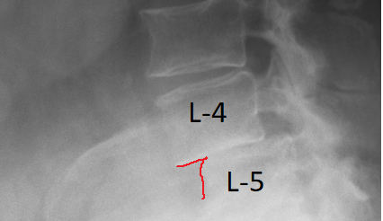
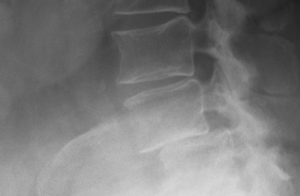
View 1
View 2
[Anterolisthesis is an abnormal alignment of bones in the spine and usually affects the lower back. It occurs when an upper vertebra slips in front of the one below. Pain is often the first symptom of anterolisthesis.
Misaligned vertebrae can pinch the nerves, and this can have painful and debilitating consequences. Other parts of the body, such as the arms or the legs, can also be affected by anterolisthesis.]

BioAcoustic Report showing L-4 as a priority. Multiple reports thru Feb-Mar show stress at L-4
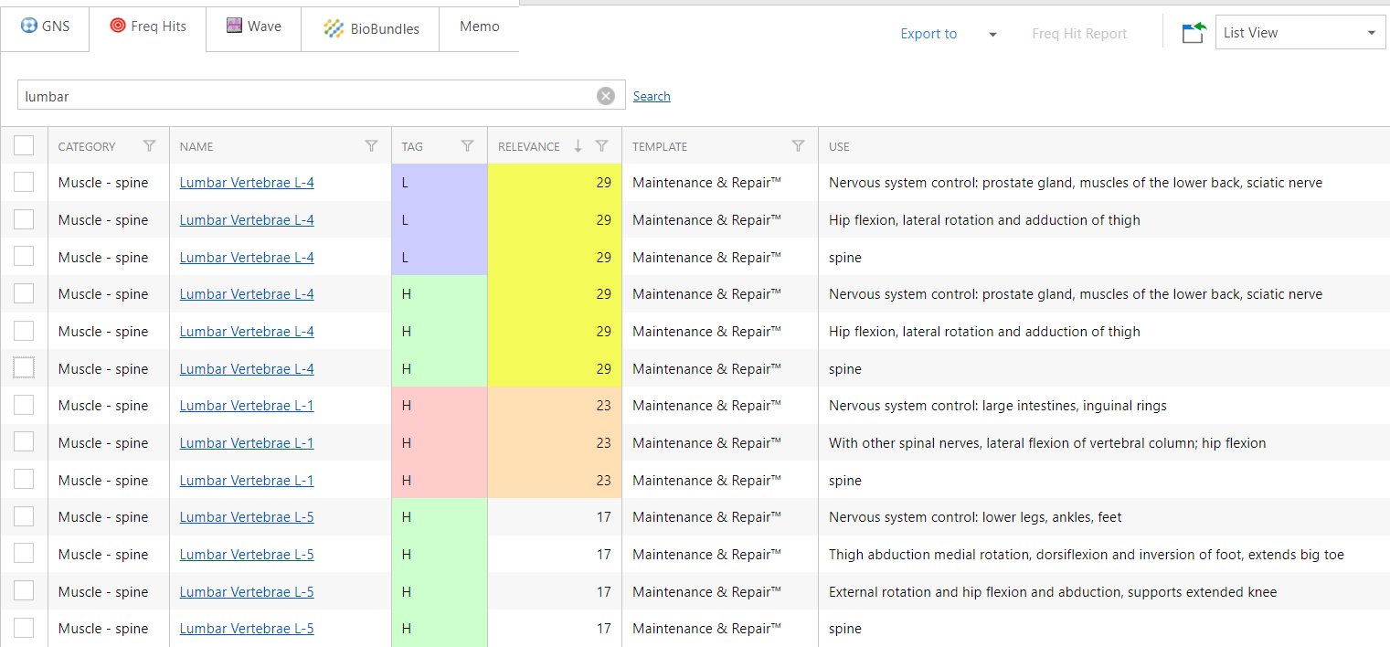
The contributing events were identified through the frequencies of the voice without expensive, intrusive machinery and showed that vocal analysis can be done remotely. 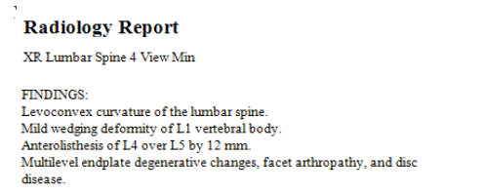
Using the frequencies assigned to L-4 and L-5 together in specialized formulations creates the frequency associated with Ankylosing spondylitis – which my grandfather and aunt lived with for many years. This brings to mind that the body is consistently Mathematical, even genetically. Could we be math-based sentient robots that can be supervised and managed using the math of the voice?

How important is the truth?
Complete Benghazi hoax perpetrated by Hillary and Obama from the airport hangar bringing back the bodies, can be found page 33, Biggest Liar – https://tinyurl.com/tswtmnhy. It was originally published by Sound Health as an untruth shortly after the event. CBS news in 2013 came under fire for exposing the false Benghazi message being perpetrated by the government.

The Magic of Math as Medicine
Trusting in math can answer questions that have remained a mystery for conventional medicine. Using math, it can be shown that the frequencies that manage the body are redundant across body systems. The Cornea of the eye and blood sugar are the same frequency thereby potentially explaining why diabetics have issues with loss of vision.
There are thousands of these mathematically relationships that explain everything from obesity to depression.

Proof of concept
Studies show that the human voice can substantiate the fact that people who share similar vocal architectures, share similar health and personality issues. These Signature Sounds were known to our ancestors. The data brings together ancient knowledge with modern ideas of harmonics and frequency relationships to show that math can be used as forms of predictive, diagnostic, and curative foundations for wellness.
Through entrainment of the frequency grids of the brain, the body can be programmed to support its own optimal form and function. The essential element is accurately identifying the appropriate/significant frequencies associated with each individual.
String theory proposes that infinitesimally small strings create our bodily structure, but it does not answer the question of how this transformation occurs. The brain communicates using the language of frequency and has the ability to reveal individual DNA/RNA templates that have the potential to promote and extend life. Sharry Edwards’ work provides many of these answers as to how these theories can be put to use to bring the Truth to the surface about who we are, how we got here and where we are going in terms of our intentions and health.
Is frequency our new medicine or an ancient mystery revealed? There have only been a few modern keepers of the Holy Grail mysteries. Sharry Edwards has been identified as one of the extraordinary beings walking the earth to bring forth the secrets kept from mankind. Her work has helped identify the hidden Codes of life that add meaning and new dimensions to our existence. She will likely be best known for her ability to bridge the gap between the ancient, the esoteric and the scientific realms of human evolution.
Her ability to hear a space is astonishing. To walk with her into a room, watch her tilt her head and then sing a vocal pure tone (supposedly impossible for a human) that causes the room to echo back is a spine-tingling experience. She can also sing the sounds of nearly any vessel, a person, a thought, compound or animal. Even though she has now crossed the bridges of 7+ decades, she is still discovering unique qualities about her voice and ears.
She laughs as she explains that she was uninvited to a sound healing conference by an organizer stating that she has no musical talent, nor did she play any instrument. Edwards’ unusual vocal abilities are likely one of the most unique musical voices on the planet. She cites her ability to “hear” the signature sound of almost anything as the reason that she has the ability to tap into the hidden nature of the universe via numbers.
Edwards believes that her work is well on the way to providing the proof that, at our core, we are very sophisticated, but mathematically managed, frequency-based entities.
She asks that we imagine a future in which we can be individually identified and maintained through our math matrix to permanently establish and maintain ourselves as healthy and emotionally balanced. Her work at the Institute of BioAcoustic Biology has shown that we can each have dominion over those frequencies by individual mind management or a simple, completely programmable remote control.
In the near future biofrequencies, as an indicator of health, will become as common as taking your temperature or blood pressure when you visit your healthcare provider. MIT, several universities, and the Mayo Clinic are working with these principles; with AT&T declaring that “bioacoustics is the medicine of the future.”
The ancient idea of Signature Sounds combined with modern techniques of Vocal Profiling utilize the premise that the body can identify and prescribe for itself using the algorithms of vocalized frequencies to accurately quantify, organize, and extrapolate biometric information.
The science of BioAcoustics brings together ancient knowledge with modern ideas of harmonics and frequency relationship theories to show that math can be used as a form of predictive, diagnostic, and curative foundation for wellness. Through entrainment of the frequency grids of the brain, the body can be programmed to support its own optimal form and function.
Edwards explains that her research supports the idea that Health for THE PEOPLE, by THE PEOPLE, is making room for self-responsibility in health care. Dissatisfaction in the present systems leads to a demand for change but we also realize there are obstacles to it. Edwards has created an open-to-the-public WorkStation that provides information and software as Tools & Solutions for Vocal Profiling that promotes SELF-HEALTH at SoundHealthPortal.com.
No one argues that our present health care system is in crisis or that people are seeking alternatives. Buckminister Fuller said “In order to change something, don’t struggle to change the existing model. Create a new model and make the old one obsolete.” Edwards, with her small, yet highly innovative educational research facility, is striving to do just that.
Edwards has created a BioAcoustics-based alternative Health Care System, she intends to share it with THE PEOPLE and leave those who insist they know what’s best for us, in the dust.
Vocal Profiling has the ability to let us know the intentions of our leaders; the motivations of our partners; the foundation of our sense of Self-Health and wellbeing. Would those abilities be of value in the struggle to attain dominion over our intrinsic right to personal freedoms?
From birth to death, we use sounds to express our needs and emotions, but there are additional layers of information hidden within the words. In modern times we possess only limited conscious awareness of this information for ourselves or as a means to interpret the intentions of others.
Vocal Profiling software has been developed that can use the components of the voice to create a matrix of information about anyone, from fundamental DNA to the hidden intentions of those who claim to speak for us.
Sharry Edwards has been accused of being too scientific by some, too esoteric by others. In actuality she is a bridge between both fields of inquiry. She is an acknowledged pioneer in the emerging field of Human BioAcoustic Vocal Profiling. She has for many years provided the leading-edge research to show the voice as a holographic representation of the body that can be used to change the face of medicine.
Edwards’ intention is to demonstrate how the present system of health and governmental tyranny is both a tragedy and an opportunity.
Our brain is the central processing unit of our body that initiates and circulates frequencies throughout our vast neural networks, providing directives and power to keep our bodies in exacting homeostasis (healthy balance). This indicates that even unspoken, thought can become our guiding force in keeping us healthy, emotionally balanced, or potentially controlled through electronic means.
We are on the precipice of learning to use the individual sounds exhibited by the body as intrinsic, individual healing directives. Edwards has opened the door to that possibility.
For centuries curious minds have attempted to compare sounds, light, emotions, disease states... with the health and maladies of the human condition.
Finding your own voice takes on new meaning if you begin to consider the possibility that the sounds of your voice may be a holographic representation of all that you are.

Everything that happens to the body reaches the brain as biofrequencies that are then sorted, routed and assigned an interpretation but it seems, in modern times, that we carry very little conscious awareness of this information. Did we as a human race forget, or were we forced to abandon, a great deal of our intrinsic abilities to glean information about another person simply by hearing their voice?
As man evolved, language became levels of intricate harmony nestled within structures of great elegance that carried meaning and allowed understanding.
Down through the generations, the idea that humans are fostered and driven by ancient numeric codes has intrigued many scientists and visionaries. The popularity of publications such as the Da Vinci Code and The Symbol by Dan Brown has sparked interest in the possibility that a great deal of knowledge has been kept hidden from all but the elite of humankind. Is the idea that we have dominion over our lives through our thoughts and intentions an intrinsic fact of human spirit? Can we in truth chant the words and create our Reality?

The obvious success of the tide-turning movie, The Secret, showed that people are ready to accept the fact that we can think or say something and have it manifest. Have we matured enough to receive the bounty of consciousness-produced reality with wisdom? Do people really know what they want, deep down, devoid of old parental “tapes,” advertising, peer pressure, the “oughts” and “shoulds” that we are subjected to every day?

If we want to manifest our neighbor’s car or wife for ourselves is this a lack of respect or our basic right of conscious intention? If we accept the reality that we all fit perfectly into the perfectly conceived, perfectly interlocking puzzle of life, then how can we allow any two people to want the exact same item? Someone would do without and therein resides a basic problem. If we both pray for the same thing, who gets the prize? So how can someone “program” their lives with the voice of prayer and mantra without bumping into the needs and rights of others?

Many spiritual leaders, throughout the ages, have claimed that we have the power to be who we want to be, to have what we want. It could be that the world is designed perfectly and if we really knew the ideal life to manifest, then
everything would be in harmony. But how can we ever know what will perfectly balance our lives? How can we know what we really want underneath the layers of greed and need?

We can find our true voice. Nothing is hidden from your own voice. You may be able to lie to your friends or deceive yourself with your words but the voice does
not lie. Vocal Profiling computer software has been built that can evaluate the frequencies, architectures and harmonics of your voice. Vast frequency-based data banks can now be used to create a report of what you really think, who you are emotionally and the status of your health. The frequencies missing from your voice are just as important as those that are present. An entire matrix of information, from your DNA to your partner preferences can be evaluated.

Using this modality, your voice can be used to reveal who you really are under the layer of public personality you have created. This is an opportunity of the human race to break free of all of the deceit and deception that we live with on a daily basis.

What would our world be like? Our legal system would be unneeded if your true voice could be so easily read: Unsound relationships would crumble, businesses would fall because for the most part, our world is built on what we can keep hidden from those who think they know us.

Vocal Profiling has the ability to let us know the intentions of our leaders, the motivations of our partners, the pathway to our sense of self. Would that be of value or an avenue toward destruction?

What would the world be like if everyone only spoke the TRUTH? Can you imagine a society where we are all known by our frequency signatures that people could read via a voice that truly represented who we are? Could finding our true voice allow us to create a world full of grace and dignity?

We loudly proclaim that truth should be valued as a virtue. Should it have taken a computer program for us to discover our internal truth and clarity?

References
- Alternative Medicine the Definitive Guide (2nd Edition) pg. 447 by John W. Anderson, June 1,2002.
- Health on the Edge, Visionary Views of Healing in the New Millennium, chapter 5 pg. 209 by Larry Trivieri Jr. Dec 29,2003.
- Helping People Help Themselves Through Sound Healing. Published Papers-
- 1993-1995. Articles By and About Sharry Edwards. By Various Jan 1,1996.
- Natural Detoxification the Complete Guide to Cleaning your Body of Toxins 2nd Edition Revised and Expanded. Pg.439 by Jacqueline Krohn M.D., Frances Taylor MA, Oct 20,2000.
- Pioneers of Recovery, Stories of Nine Pioneers Who Reversed the Symptoms of Parkinson’s Disease. Pg 94. By Robert Rogers, Ph.D. 2012
- Secret Sounds-Ultimate Healing. Your Personal Guide to A Better Life Using Sharry Edwards’ Revolutionary “Secret Sounds” by Jill Mattson, Nov 17, 2011 and in June 13, 2019.
- The Duke Encyclopedia of New Medicine, Conventional and Alternative Medicine for All Ages. Pg 556, Forward by Tracy W. Gaudet, M.D. 2006.
- The Lost Waves of Time. The Untold Story of how Music Shaped Our World, Chapter 1 by Jill Mattson, March 21,2006.
- The Scientific Basis of Integrative Medicine 1st Edition (Sharry Edwards 1997) by Lucy Anderson, M.S.W. March 27, 2007.
- The Tree of Life and The Holy Grail pg. 199 by Sylvia Francke and Simon Blaxland-de Lange Dec. 17, 2020.
- Vibrational Medicine, Third Edition, The #1 Handbook of Subtle-Energy Therapies. Sharry Edwards’ Signature Sound Works (Uses “Bio-Acoustic” analysis of a person’s voice print to determine a person’s therapeutic sound frequency or soul note.).
- E-mail: soundhealthinfo@gmail.com by Richard Gerber, M.D.
- McArthur newspaper
- Bruce Lipton book
- Albert Roy Davis book
- Lynn McTaggert book
- https://www.msn.com/en-us/movies/celebrity/robin-williams-suffered-from-dementia-in-his-final-days-says-new-bio/ar-AAwQuSy?ocid=spartandhp&ffid=gz
- The Benghazi Hoax Chapter 16: 60 Minutes by David Brock, Ari Rabin-Havt, and Media Matters Staff, December 6, 2013.

BioAcoustics doesn’t have all of the answers but has enough to know that we have a very good beginning to provide proof of concept of healing through frequencies. For the astute healer or investor, taking on the task to bring this to the world should be a no brainer.

We need practitioners and trainers.

Online WorkStation created for Sound Health & Sound Healers
Bringing together New Medicine and Ancient Healing Mysteries
The automation of Ancient Healing Methods

Input your voice and receive a personal, computerized, quantifying report of your own vocal BioMarker anomalies.

Bringing ancient methods of sound healing into the modern era has been a challenge for those who “hear the call” to use sound to make a difference in the lives of those who need support and healing.

Jill Mattson’s publication, Lost Waves of Time, is more than a superb rendition of ancient healing as she also takes you through the eons of healing practices throughout several continents and populations. Mattson reports that in early cultures, healing was a matter of intuition and/or being in touch with universal connections that was once prevalent and used by special appointees of a given community. In some cultures every individual was assigned a “Signature Sound” as part of their spiritual identity.

Healing Masters are still here today but are often “interrogated” by those who consider themselves to be a part of a “legitimate” medicine society. These modern-day practitioners depend on statistical validation for diagnosis.
Enter The Institute of BioAcoustic Biology, under the tutelage of Sharry Edwards, MEd, who has been investigating the idea that the frequencies of the voice are a holographic representation of the body’s form and function. Over the years she has gathered information which indicates that the voice can potentially be used as a diagnostic tool but could potentially provide sound-based solutions for health.

In 2004, The Institute published the tenet that "People with similar wellness issues produce similar vocal biomarkers.” This suggests that the sound frequencies produced by a human voice could be used to identify and quantify the wellness status of a person or find the commonalities for a group suffering from similar maladies.

MIT and the Mayo Clinic, among many others, have taken on the task of providing proof of Vocal BioMarkers for use by conventional medical models.

Edwards, the established pioneer of Human BioAcoustics, has taken on the task of bringing the information she has amassed to the public for their use to self-predict, manage and have dominion over their own health and health freedoms.
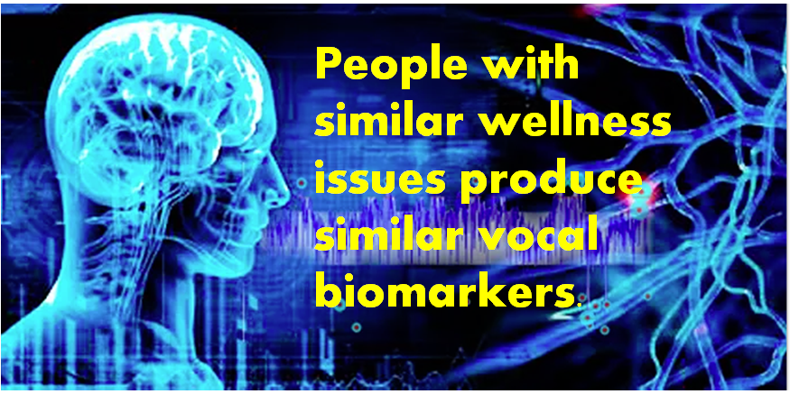
The online Portal is open to the public at SoundHealthPortal.com. It includes tutorials, evaluations, documentaries, campaigns, articles, and references plus the opportunity to scan your own voice for errant frequencies (sour notes). Input your voice and receive a personal, computerized, quantifying report of your own vocal BioMarker anomalies.

The Sound Health Portal presents the opportunity for Sound Health LIVE! while offering innovations that bring a balance between science and esoteric.

Portal Solutions include
- All issues reported as Frequency Equivalents™ from the tenets of BioAcoustic Biology
- Well over 100,000 frequency-based entries divided into multiple bundles including sports, pain, weight management, circulation, stem cells, regeneration, respiration, toxicity, reproduction… hundreds more
- Online presence to allow your clients/patients to deposit vocal prints from their location
- BioAcoustic Bundles to allow you to search and compare several body systems
- Allowed intuitional input with statistical support
- The process of Gathering and Evaluating vocal Frequencies automatically
- BioMarkers that provide a priority listing of issues
- Advanced materials that reveal underlying issues

AVAILABLE 24/7 online!
Tutorials
Public workshops
Textbook
Corporate accounts
Sports evaluations
Mobile evaluations
Built-in reference library
Online data storage
Mobile client input
30-day trial period

Comparison of long-term data
Automatic priority listings
Professional version with frequencies, formulations
Graphs, notes, charts and reports
Translation to other languages
Help to find root and multiple root cause
Public Nutrition and Muscle templates included with free Subscription
Personality Profiling
Taught by Sharry Edwards

Everybody has a sound!

Miracles of non-Medicine --- https://vimeo.com/126935179
Link to a few Portal presentations:
Good Vibrations--- need link
Comprehensive Portal Video Link - https://vimeo.com/311315908
Golf Swing Portal Class - https://vimeo.com/325944186
Sound Healers Portal Video Link - https://vimeo.com/322353431
In the Beginning – https://vimeo.com/267137390

Articles:
MS eye issue reversed
Any other suggestions?

BIO –
Sharry Edwards is well on her way to proving that at our core we are very sophisticated math-based robots. She states that we can be “managed” through our individual frequency-based signatures.

She asks that we imagine a future in which we can be individually identified and maintained through the use of frequency-based biomarkers that keep us healthy and emotionally balanced. Her work at the Institute of BioAcoustic Biology has shown that we can each have dominion over those frequencies by individual mind management or a simple remote control that is completely programmable. Using the unique techniques of Vocal Profiling and evaluation, emotional as well as physiological issues can be revealed and addressed.

Her work with the human voice reveals an important BioAcoustic theorem: that people who share similar traumas, stresses, diseases, toxicities…share similar, if not identical, vocal anomalies. She brings together ancient knowledge with modern ideas of harmonics and frequency relationship theories to show that math can be used as a form of predictive, diagnostic and curative foundation for wellness. Through entrainment of the frequency grids of the brain, the body can be programmed to support its own optimal form and function.

String theory proposes that infinitesimally small strings create our bodily structures but doesn’t answer the question of how this transformation occurs. The brain communicates using the language of frequency and has the ability to reveal individual DNA/RNA templates that have the potential to promote and extend life. Sharry’s work provides many of these answers as to how these theories can be put to use to bring the Truth to the surface about who we are, how we got here and where we are going in terms of our intention and health.

Is frequency our new medicine or an ancient mystery revealed? There have only been a few modern keepers of the Holy Grail mysteries. Sharry Edwards has been identified as one of the extraordinary beings to walk the earth to bring forth the secrets kept from mankind. Her work has helped identify the secret codes of life that add meaning and new dimensions to our existence. She will likely be best known for her ability to bridge the gap between the ancient, the esoteric and the scientific realms of human evolution.

Can Tiger’s Swing be Improved?
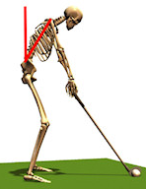
Why did Tiger Woods lose the 2009 PGA Championship? During the press conference directly after the loss, Tiger himself didn’t know why he lost; why is he was unable to execute those last two holes. He may never know the reasons but a pioneering technique of BioAcoustic Biology and vocal profiling may be able to reveal the answer.

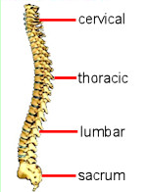
A Vocal Profile, which examines the infrasound and harmonic biomarkers of verbal communication, was performed which verified several issues that could have contributed to his less than stellar performance. Several vertebras that support a golf swing were identified as structural problem areas: Lumbar-1 showed to be weak while, Sacral-1, Thoracis T-6 and T-10 all showed to be over stressed. The Thoracic vertebrae allow for the rotation of the spine in the upper back; the sacral and lumbar regions act to limit rotation in the lower back. Tight muscles also contribute to potential injury of a muscle.

Experts agree that optimal positioning and mobility of the spine is a significant factor in the optimal and accurate performance of an accomplished golf swing. Woods’ training team would be wise to use stretching exercises to release the tight ankle, pectoral and deltoid muscles that were identified as being in stress. Specifics of his report are available from The Institute of BioAcoustic Biology – 740-698-9119.

Using the frequencies of the voice can often reveal information about a person’s structural or biochemical status when conventional medical care cannot determine the cause. Woods’ televised PGS press conference provided a fresh sample of Woods’ voice for evaluation. “The fresher the vocal print after an event the more accurate we can be” stated Sharry Edwards, the acknowledged pioneer of this novel technology.

Sound Health, the company that executed the analysis of Woods’ vocal frequencies is located in Albany, Ohio. It is the largest alternative health research facility in Ohio and has been recognized by Ohio’s BioOhio Technology Division as being among the most innovative biotech companies in Ohio. Edwards has received many awards for her work which has appeared in nearly 30 books, countless publications and more than a dozen documentaries. The company sponsors an on-line Journal that can be found at www.jbab.org. The most current issue features several articles dealing with joint pain alleviation and muscle mobility. The articles detail how sound waves have been successfully used to increase (or decrease if need be) muscle strength and action.
“The fresher the vocal print after an event the more accurate we can be”

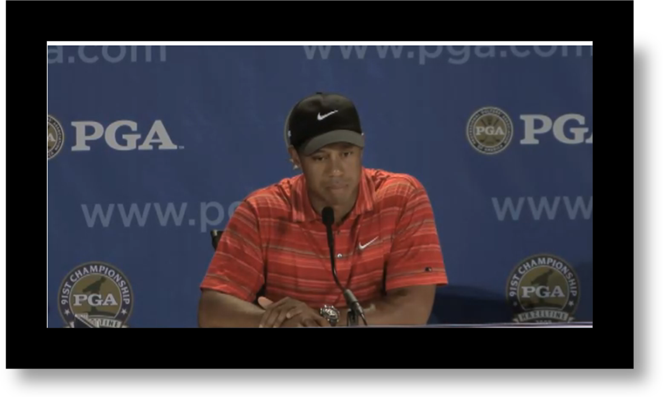
http://www.med.nyu.edu/hjd/hjdspine/education/anatomy/bonesanddiscs/vertebrae.html
http://www.springerlink.com/content/q63lt4585142k120/
http://perfectgolfswingreview.net/weight.htm

NanoVoice software was used for this evaluation. NanoVoice is a Vocal Profiling personality survey developed by Sound Health and the Institute of BioAcoustic Biology. A complimentary copy of the software can be downloaded at nanoVoice.org.

Tiger's apology
Recording Date: 02/28/2010
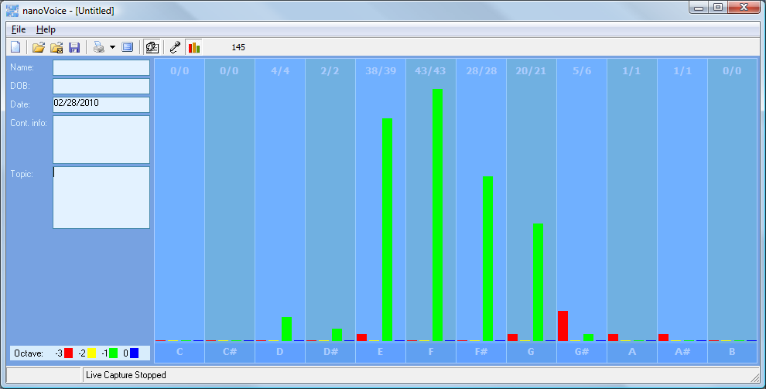
“My real apology to her will not come in the form of words. It will come from my behavior over time.”

Manual printout – this statement was uttered for a long-term purpose that was planned and executed with a useful goal in mind. The planning and execution of that plan using words was for a specific purpose of safeguarding some physical goal.

Computer print-out
Tiger apology
Recording Date: 02/28/2010
Subject/Topic: Tiger: “My real apology to her will not come in the form of words. It will come from my behavior over time.”

Missing Notes
You have no hits for the note(s) of: C, C#, B. Either you did not take enough samples (100-500 is usually best) or your subject matter did not include thoughts or topics that would involve this/these note(s). See the Note Correlate Chart that appears on the Cover Page for more explanation.

Points of Importance, Attention and Consequence
Your highest note is associated with the integration of appropriate perception and action. The ability to assess a situation quickly resides with this note. Your highest note deals with expression through words both written and oral. The world of creative self-expression resides with this note. Your highest note is associated with the expression of duty to work and accomplishment. The ability to see the flaws in a plan and make it right resides with this note.

Being able to prioritize what needs to be done emotionally is not always easy for you. You may be caught once in a situation but you aren't often caught twice without a proper answer.

You do what you do for the benefit of all concerned, even if it stresses you personally. You wish for the best which sometimes leads to statements of hope instead of statements of fact.

Tiger apology to friends
Recording Date: 02/28/2010
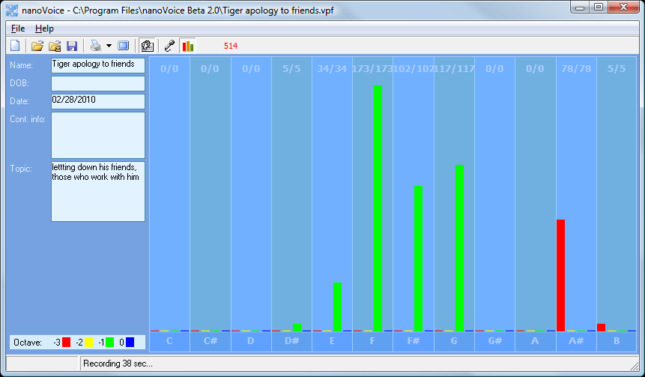
Subject/Topic: letting down his friends, those who work with him
Manual print out – some of this apology was spontaneous (A#) and spiritually felt in the moment. This was more planned than the apology to his wife but not as constructed. He doesn’t want to talk about this, just go through the motions and get it done because there is the future to think about.

Computer print out
Your highest note is associated with the integration of appropriate perception and action. The ability to assess a situation quickly resides with this note. Your highest note is associated with the expression of what you consider to be your physical domain. Having dominion over your physical environment resides with this note. Your highest note is associated with the expression of duty to work and accomplishment. The ability to see the flaws in a plan and make it right resides with this note.

You may be caught once in a situation but you aren't often caught twice without a proper answer. Those around you will allow you to give too much unless you define your own needs. You tend to do more for others than they do for you. The right words at the right time can sometimes elude you because of all of the internal dialogue.

You wish for the best which sometimes leads to statements of hope instead of statements of fact. Your connection to universal truths demands your time. You wish someone could understand you without demanding a lot of conversation.

Tiger-bitterly disappointed
Recording Date: 02/28/2010
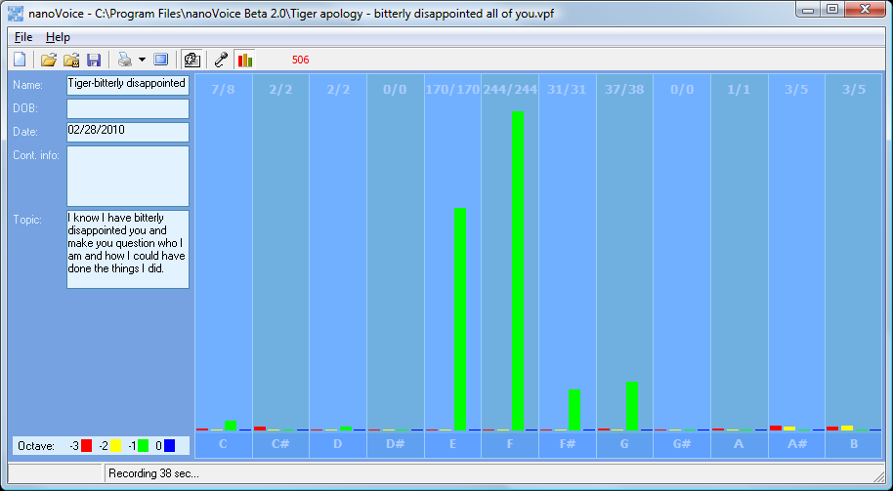
Subject/Topic: I know I have bitterly disappointed you and make you question who I am and how I could have done the things I did.

Manual: more of the same – use words for a future goal or purpose

Computer print-out
It is easy for you to see the faults in others but don't always know how to get your point across politely. If you ever had to lie to see justice done, you would do it but your sense of justice does not always jive with the law. Your stamina to get things accomplished is admirable.

Your highest note is associated with the integration of appropriate perception and action. The ability to assess a situation quickly resides with this note. Your highest note deals with expression through words both written and oral. The world of creative self-expression resides with this note. Your highest note is associated with the expression of what you consider to be your physical domain. Having dominion over your physical environment resides with this note.

Being able to prioritize what needs to be done emotionally is not always easy for you. Your metabolism shows be a weak point in your vocal print. You don't always express your sense of confusion to the appropriate person. You can sometimes do too much for others in the hopes of helping them change.

You would like to have more time to spend on spiritual things. You have a hard time prioritizing what you want to do first. It is hard for you to understand why people take your peaceful nature as being an easy target. You can be very hard on yourself - taking blame or responsibility needlessly.

Tiger - I am so sorry
Recording Date: 02/28/2010
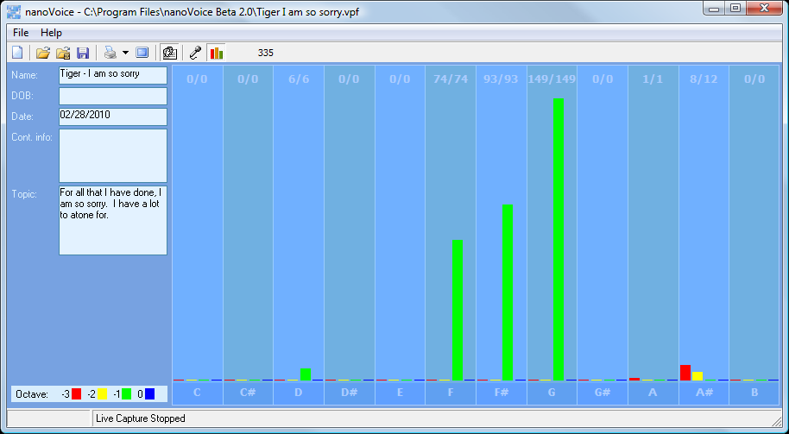
Subject/Topic: For all that I have done, I am so sorry. I have a lot to atone for.

Manual: This statement was planned and orchestrated to carry out a physical goal.

Your highest note is associated with the expression of what you consider to be your physical domain. Having dominion over your physical environment resides with this note. Your highest note is associated with the expression of duty to work and accomplishment. The ability to see the flaws in a plan and make it right resides with this note. Your highest note is associated with the integration of appropriate perception and action. The ability to assess a situation quickly resides with this note.

Tiger about abuse from wife
Recording Date: 02/28/2010
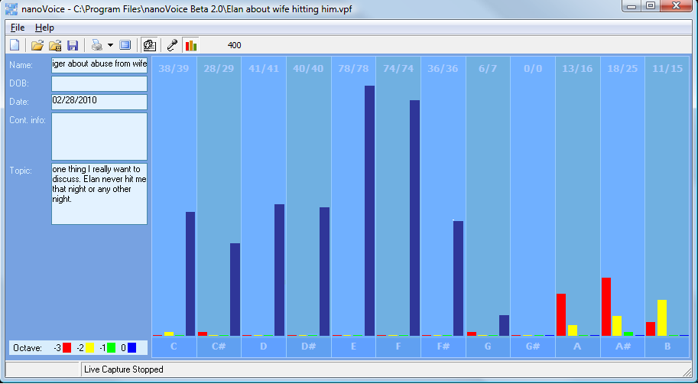
Subject/Topic: one thing I really want to discuss. Elin never hit me that night or any other night.

Manual: his emotion is about his wife’s reputation. He is highly emotional about people thinking his wife did anything to him. He is protecting her, feels this is his duty. Feels responsible that anyone would think that he perpetuated his wife in this light.

Computer print-out:
Your highest note is associated with the expression of Self Approval and Self Worth. Issues of digestion, enzyme and energy production reside with this note.
Structure is not required for you to be comfortable. Those around you will allow you to give too much unless you define your own needs. You tend to do more for others than they do for you. Being able to prioritize what needs to be done emotionally is not always easy for you. Your metabolism shows be a weak point in your vocal print.

Composite below shows that the general thrust of his speech was emotional. It was hard on him to do this. Two intentions show up: to protect the future of something physical that deals with his friends, his fans and those he works with AND to emotionally protect his wife’s reputation. It is important to him that his physical environment remains useful. There is some high spiritual energy going on here. He seems genuine that he wants to preserve his future and he is now engaging his emotions to see that his goal becomes a reality. Maybe he has finally realized that although the rich and famous get away with playing with different rules, those people around him will not tolerate that behavior.
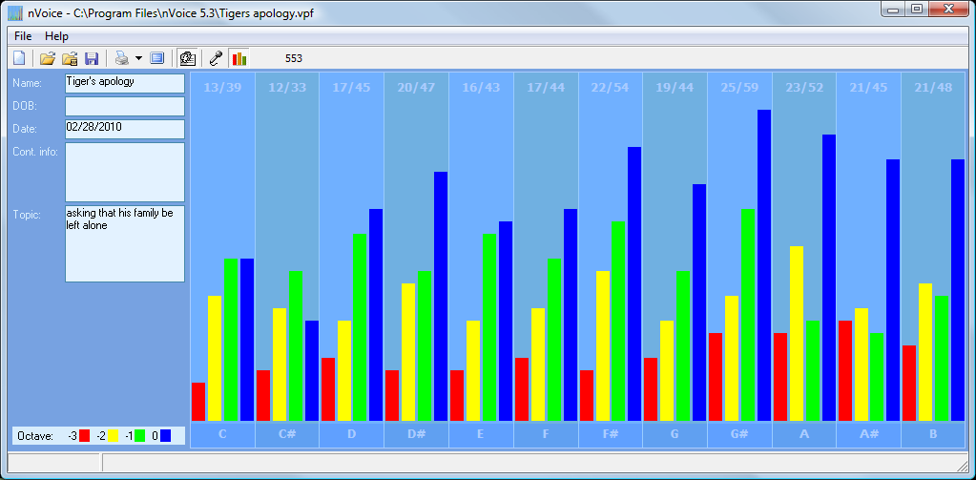
Subject/Topic: asking that his family be left alone

Points of Importance, Attention and Consequence
You want everything done but you do so much that some things don't get done on time. You can be fussy about your physical space. It needs to satisfy you and no one else. Sometimes you spend a lot of energy trying to get even the smallest detail right the first time. You have an unusual sense of time. Not having all the information needed to make a decision stresses you. Your reputation is very important to you. You will go to great lengths to protect it. You push yourself and others to finish the job. You love new ideas that mean you can have a project to work on. A sense of belonging is important to you. Your highest note is associated with the expression of physically prioritizing what you need and want to accomplishment. Personal control over what happens in your physical environment resides with this note. Your highest note is associated with the expression of your internal perspective of insight and self-awareness. Internal faith, fairness and fulfillment reside with this note. Your highest note is associated with the expression of duty to work and accomplishment. The ability to see the flaws in a plan and make it right resides with this note.

You sometimes depend on others to support your place in the world. You can see how a situation needs to play out but you don't want to seem interfering. You don't always express your sense of confusion to the appropriate person when others attempt to deal with you inappropriately. Sometimes you think you might as well be invisible when you spend your energy to help others because they don’t seem to be listening at the moment. You want to do something about the mess the world is in but just don't seem to have the energy. Your leadership ability is hampered by lack of opportunity. The right words at the right time can sometimes elude you because of all of the internal dialogue. You would rather not talk than say something useless.

Points of Communication, Complications and Complaints
You have the ability to organize and prioritize in your head. It may not look that way to others but it is your mode of operation. You like to organize yourself so that everything is at hand and easy to utilize. It is particularly bothersome when people use or borrow your property without permission.

You are capable of pushing yourself to get things done. Creating new projects from the ideas you generate is rewarding. You take pleasure in changing things for the better.

Seeing every side of an issue is important to making the right decision that is for the betterment of all concerned. You can easily put yourself aside for the benefit of others. You can be good counsel for others if you allow them to keep their own systems intact and not insist they follow yours.
You don't always know how to fight back to secure what is properly your due. It is hard for you to understand why people take your peaceful nature as being an easy target. As long as a rule doesn't pertain to you or yours personally, you don't often bother to object. You very much appreciate those who come to your verbal rescue.

You like to contemplate an issue before you speak up. You are sometimes reluctant to take the lead. You have good ideas but are sometimes reluctant to speak up. You like the idea of leadership but sometimes take on more than you expected to contribute.

You like praise but don't always know how to accept it humbly. You don't always know what words to use to express what your real needs are. You would rather they just be provided. You wish someone could understand you without demanding a lot of conversation.

Points of Cooperation, Learning, Opportunity and Growth
You dislike being accused of something you did not do because it hurts your spirit. When you are satisfied with your decision, you no longer need to talk about it. You have the ability to influence others from a spiritual perspective.

You have the ability to perceive what others may be thinking and can use it to your benefit. Your verbal skills make you a good trainer. You have the ability to play word games. You would make a good mediator.

You like reciprocal relationships but often give more than you receive. You can be incredibly generous if your generosity is appreciated. You give of your time and organizational skills easily for a good cause.

You have a natural knack for planning. You like helping others do for themselves. Working for a cause usually puts you out front because of your organizational skills.

You are willing to spend a lot of your time making sure that others learn about integrity, wisdom and responsibility. You challenge yourself much more than others challenge you. You love seeing all the pieces fall together to make it all work.

Getting to the core of what you really believe to be the right way of life is important to you. There are times when you disregard your own needs in order to help others. It is important to you that you make a difference in the lives of others. To help them move toward a more unselfish life. You are a natural teacher by example. You have a patient outlook on life and can work toward a specific goal without regard for your own needs.

You can use words to help others find their path. You can go to a deep internal space using self-dialogue. You can talk others into carrying out the details. You can envision an end result but don't want to be required to explain everything in detail.

You work to see that others are not taken advantage of. Writing that flows freely to you can also help move others towards their own inner strength. Your self approval depends on living from the inside out - from the core of your being. You have a great ability to learn from your own mistakes and move on.

Spiritual laws and what's RIGHT are more important than Man's laws. Protecting people's feelings is very important to you. You ability to help others through emotional turmoil is admirable.

You like to get things done but need a plan first. You don't like people interfering with the way things need to get done. You don't mind helping but you don't want to be kept to a schedule or plan that is not your own.

You have a tendency to think you ought to fight authority to prove personal points of honor even when it costs you. Joining a group that thinks like you do will help bring justice to a situation. Your own self approval issues can get in the way of expressing your opinions that need to be heard. You can be quick to judge before you gather all the pertinent facts. In most cases it is a lack of understanding your motivations.
You have good intention about bringing your plans to fruition. You seem disorganized to the casual onlooker. You would like more options about your physical surroundings.

Being aware of how others will take what you say is of concern to you. You have a knack for teaching by demonstration. You can easily take charge of a physical situation using words.

You have the ability to go deep within to find answers about your direction in life. Being perceived as a solid and resourceful person is important to you. You strive to balance what others want from you with what you know to be your destiny.
Your stamina to get things done is admirable. Others see you as a balanced and busy person. Your motivation sets a good example.

You can get involved quickly without knowing all the facts when you perceive an injustice. Those around you attempt to influence you through your emotions. When you think what has happened is unfair, your first thought is to make things right. You do this without thinking about how your actions will be perceived.
There are indications that issues with cellular oxygenation may need monitoring. Identifying which foods are most compatible with you is important to your digestive health. The process of digestion needs to be considered via enzyme evaluation.

