October, 2025 keynote

Color association: green blue

Musical note association: G

Astrology Association: Scorpio

Proposing a Rosetta Stone of health & healing

Susan Alexjander for her musical composition, Sequentia, created music based on the mathematical composition of human DNA. The music is haunting yet familiar to almost anyone who listens to it. I would like to share in this article, How the math created by the movements of the planets created the vibrations that became music, that became matter that became us; both emotionally and physically.

But let’s start at the beginning.

Let’s start with the concepts of Pythagoras and Johannes Kepler – two ancient visionaries who proposed that the movements of the planets in our solar system created vibrations that could be measured as music that we could not hear but vibrations that our soul recognized. Both considered that the vibrations of the planets created our physical reality.

Hence everything we experience and conceive is made up of vibrations that are measurable frequencies. This was a concept that in modern times was embraced by brilliant luminaries such as Einstein and Tesla. Both believed that to understand anything, we must first consider that everything is energy measured as frequency. How can we use this information to explain that we and our physical universe actually exist?

The Center for BioAcoustic Biology & Sound Health has been pondering this question for the last forty years.

The Institute has amassed enough data to confirm that living beings possess a Mathematical Constitution and that our research and data can substantiate that there is a Mathematical Rosetta Stone of being; of health and healing.

My ears and vocal cords are mutated so that I can hear and duplicate the otoacoustic emissions – aka Signature Sounds in ancient times - that are emitted by most living beings. I’ve used that talent through the years to create protocols and computer applications to measure frequency signatures, via vocal analysis, that have proven that frequency and vibration of our cells can be detected, quantified and used to verify and manage our emotional and physical selves.

## James Gimzewski, a **Distinguished Professor in the Department of Chemistry and Biochemistry at UCLA**, confirms that living cells make distinct sounds, which might someday help doctors “hear” diseases. He reasoned that although a noise generated by a cell would not be audible, it might be detected by especially sensitive instruments.

Through Wikipedia, Gimzewski states that cell sounds are theoretically within the range of human hearing. "So all we're doing is turning up the volume," he adds. Gimzewski reports that cell sounds might eventually be applied to diagnosing diseases such as cancer, which is believed to originate with changes in the genetic makeup of cells.

Researchers like Gimjewski are just beginning to embrace the idea that human cells can create frequencies. I think our ancestors knew and used this knowledge long ago but the information has been lost. I want to bring back this awareness so that it can be shared globally. With that aim in mind, all readers are welcome to download the software, classes, texts and videos that we have amassed. Our professional web site is BioAcousticSolutions.net.

Pythagoras and Kepler both proposed that as the planets orbited in our solar system they set up sub-audible vibrations that could not be heard with our ear but were attuned to our soul which heard it and attempted to quantify the sounds as music – Pythagoras created musical scales, Kepler cited Music of the spheres – using phrases like Cosmic choir, celestial mechanics, defined as cosmic harmony that people could use to recognize global kinship.

As these frequency layers and relationships were created they in turn created matter and hence life. In other words, the planets created frequencies and oscillations that could be defined and understood. Hence we created music in our own planetary image. Tesla and Einstein agreed that our universe could only be understood as energy measured as frequency and vibration.

Robert O. Becker, MD used this foundation to state that we have an analog body of frequency that is used for creativity, healing acupuncture, homeopathy, laying-on-hands healing… He postulates an analog body that connects us to our intrinsic self and all that is matter. Becker writes that we humans perceive and heal ourselves through an analog body.

This energy can be found in our brain and nervous system with the crossroads being the Vagus nerve that is activated during meditation, heightened awareness, prayer and states of bliss. This ethereal “system,” when activated, joins with our physical body to create our reality.

In 2006, a bestselling movie, *The Secret*, hinted that our thoughts and emotions can create our actuality. Reviews speculated that something in the movie sparked a secret memory of how we create our own reality.

Sounds, that we vocalize, move through our recurrent laryngeal nerve and those frequencies can be considered a holographic representation of our physical and emotional bodies. This nerve monitors the body’s homeostasis and can be measured as an indicator of our overall health and wellbeing. Our brain, central nervous system and body are measurable vibrations.

My undergraduate degree is in interpersonal communication - I noticed during a class on persuasion that the voice had distinct characteristics when someone was lying.

My thought was how important the Truth is to our quality of life and freedom from stress. In 1982 I decided to create a computer application, the nanoVoice, to try to test this hypothesis. I believe to this day that the Truth will unite us and set us free; but the lack of Truth will continue to make us miserable and confused.

We have proven that the nanoVoice software can reveal personality through layers of sound patterns we recognize as speech.

Each note spoken by a voice has meaning, influence and a physical attribute.

Tucker Carlson, a US TV personality who was reportedly fired from Fox News for not telling the truth, says we should “hone our Spidey senses.”

*“The truth “hums” inside of us like a tuning fork. The only reason we don’t act on it is because we have been talked out of it by professional liars. Tucker states, ’We doubt our own gut instincts! He suggests that we all need to “hone our Spidey senses.’ He cautions us to remember that misinformation should immediately be labeled as a deliberate lie.”*

Truth should be available to everyone. Lies hurt and bewilder us. Every one of us can likely remember a time when a lie cut deeply; sometimes irreversibly. The computer application that I created and tested extensively will not likely reveal something you don’t already know or at least, suspect. It will simply provide confirmation!

Below is a vocal print of Desmond Tutu using the nanoVoice software which shows his general perspective. A computer printout reveals that he is “Future oriented with lots of feeling of compassion and concern for how we treat each other.” Nothing you didn’t know but it confirms, with a computer analysis, what people perceived already. What a wonderful ability – to know and Truth and have it confirmed.

**“The TRUTH will set you free.” -John 8:32**

Compare with Zohran Mamdani’s vocal print – he is currently running for mayor of New York City. His words don’t necessarily match what people report they feel when they hear him speak. His words often create cognitive dissonance for the listener. His Vocal print shows a lack of foundation which isn’t likely identified openly by the listener but the computer program recognized and reported it.

Which person would you be more likely to Trust as a leader?

Our research has been able to develop a math matrix of a human voice – which led us to the idea of a mathematical Rosetta Stone of health and healing. This information indicates that we have a Mathematical Constitution that can be detected and managed through frequency formulations.

From a database of thousands of vocal prints, we have been able to extract math patterns of disease: cancer, vision disturbances, muscle regeneration, energy patterns, diabetes, PTSD, metabolism conflicts … Just as there are chemistry pathways of disease and unbalances; we have been able to create **Mathways** of health and personality issues. This is what we share in our classes – many of them free.

Over the years we have been able to establish that certain frequencies correlate to physical and emotional issues – they relate to music notes, colors and personality traits – many even match astrology associations. Below is the chart that can be used as a comparison sheet.

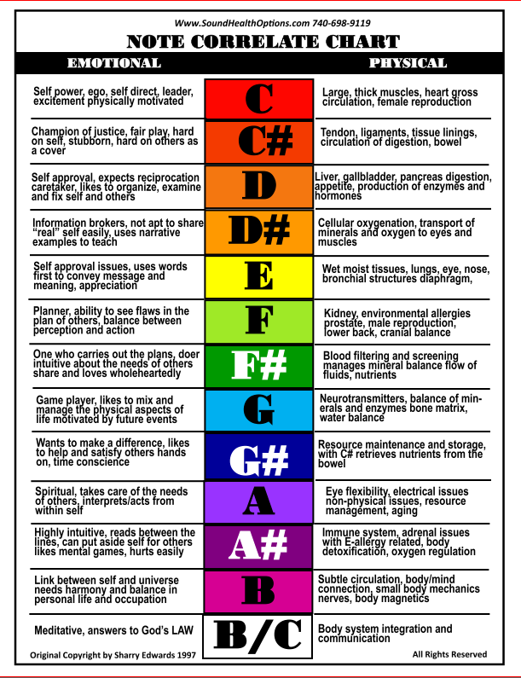

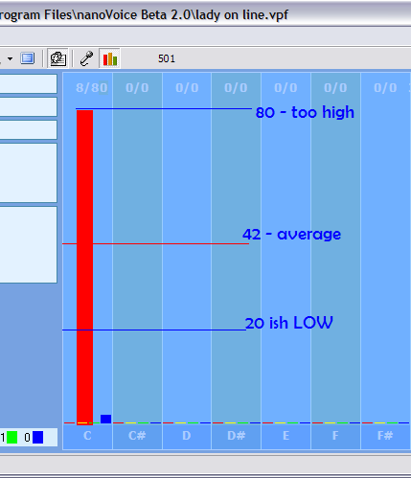

A Note Correlate chart shows not only notes but associated octaves show strong relationships to overall perspective. How much of a note appears is important but the balance of the notes is paramount to understanding the person on multiple levels.

The COLOR associated with each note is an important part of the evaluation.

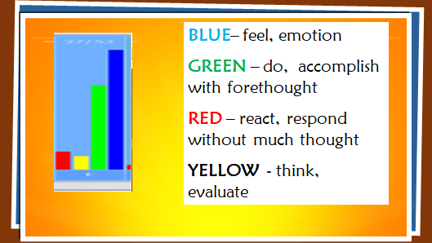

Batman actor, Christen Bale’s, voice evaluation shows balance but a dominance of green which represents a need for accomplishment. He was not angry with a photographer as reported. This was simply a publicity stunt.

**Christian Bale**

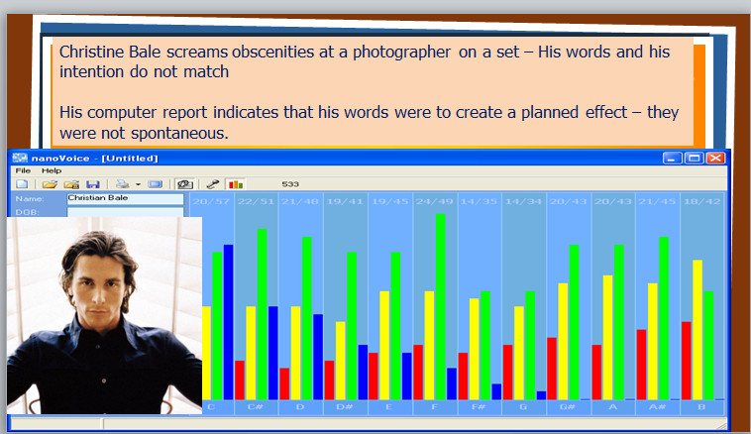

**Jerry Sandusky**

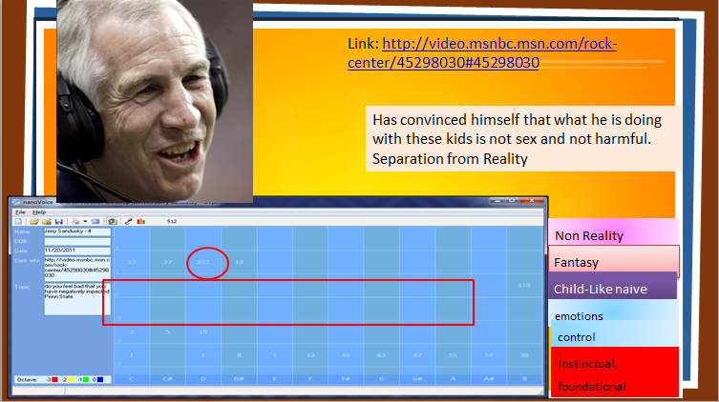

,

,

E

C

ty

Jerry Sandusky, a Penn State football coach, who was found guilty of inappropriate behavior with a minor has a complete octave of his voice missing, showing he did not tell all of the Truth. His print also indicates that he didn’t think his actions were out of line. The actual word that gave him away was “horseplay.” He thought his actions were acceptable.

The above evaluations were done using Time Domain assessments which show each sound as it is spoken. It is more of a generalized music note based evaluation. “How Now Brown Cow” would create four indicators on the voice graph.

A Frequency Domain evaluation shows thousands of indicators and is used to look at a more in depth analysis. More at: <https://tinyurl.com/yc6y8syw>

**Robin Williams**

Below are Robin Williams’ frequency and time domain vocal prints. He has high notes of B indicating high intelligence capable of a witty rejoinder. There is a lot of emotion and information there but he is holding something back. The chart is not balanced. 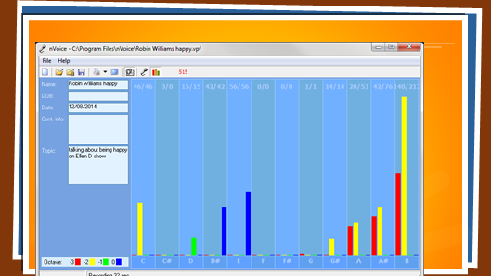

The frequency domain print of the same recording shows four spikes in the beginning of the chart which indicates brain stress. The voice print was recorded four years prior to his suicide but they choose not to share that information. In this case, the architecture of the chart is very important.

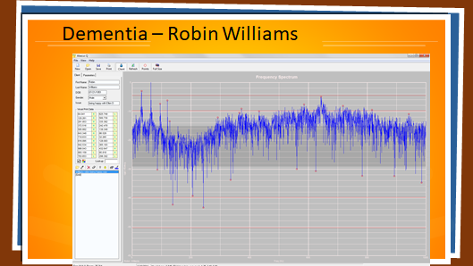

Frequency domain Vocal Analysis can provide in-depth BioAcoustic evaluations for physical and metabolic issues.

**Missed diagnosis**

Using Frequency domain BioAcoustic analysis can often confirm or deny a medical diagnosis. Such is the case for Russ Rudy, MD who was diagnosed with multiple sclerosis and was told to go home and prepare for the worst. His vocal analysis showed that he actually had an injury to his spine which he initially denied. He later remembered a skiing accident and began sound presentation to help his body heal the spinal injury. He was able to have the implanted Baclofen pump (for pain) removed as his body began to recruit his spinal nerves.

Rudy’s own words:

***“In May, 2005, I had an EMG that showed that the nerves to my quadriceps had completely regenerated. The nerves of the tibialis anterior (front muscle of the leg below the knee) had completely regenerated and the nerves of the muscles in my calf were regenerating at a rate of 3:1. This is something that we don’t expect yet mine are healing.”***

***“Physicians rarely think of themselves as patients. Unfortunately it was necessary for me to become a patient in 2001. As an emergency physician, I had enjoyed good health all of my life except for the usual minor cold and flu bugs that we all get. Thanks to Sound Health of Albany, I’m back to work.” Russ Rudy, MD***

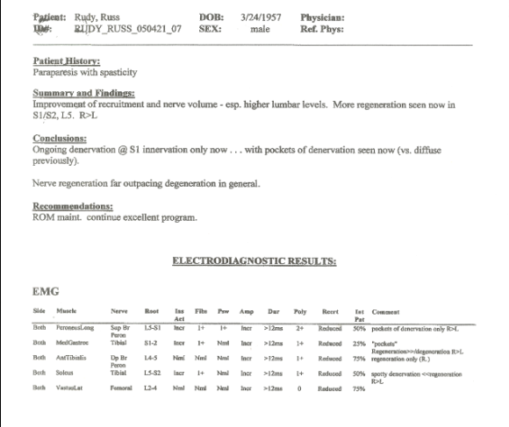

***Lab work for Dr. Rudy confirming nerve regeneration, something supposedly impossible in cases like his.***

***Injury Recovery***

Recovery from catastrophic, traumatic injuries has also been confirmed. Bob Bethel, an attorney and avid tennis player, was severely injured in a motorcycle accident. The medical establishment wanted to amputate his leg but he refused. Instead reconstructive surgery used muscles from his back to reconstruct his leg. Nearly two years later, he was still hobbling, taking lots of pain pills and unable to return to his normal life.

Bob was approached by Bill Edwards, Sharry’s husband and also an avid tennis player, in the dog food isle at the local grocery – they both had on tennis logo shirts. Bill convinced Bob to attempt to rehabilitate his tennis game. After watching and listening to them talk as they were tentatively bouncing a tennis ball around, Sharry surreptitiously played sounds that she thought would assist Bob with his pain. She had used her unusual talent to listen to Bob’s voice on the court and ascertain these frequencies. To Bob’s surprise, he was a skeptical attorney after all, his pain began to subside. Bob continued to use the sounds Sharry had prepared and within a short time his pain subsided completely and his calf muscles began to reshape. Today Bob teaches tennis again as a high level coach.

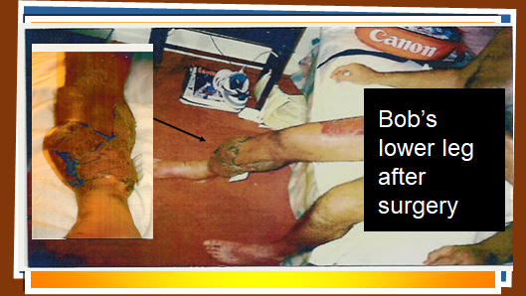

Close up of leg and foot

Bob’s reconstructed leg after surgery

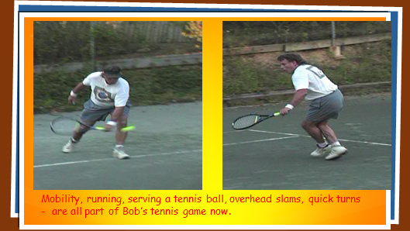

Bob’s rehabilitated leg after a few months of sound presentation

**Current Projects**

Think of this as a promising outcome for trauma and sports injuries.

**Current Projects**

One of our most current, comprehensive and useful projects is Weight Management. It is estimated that over 80% of the US population is concerned and unhappy with their weight. Worldwide the number is more likely around 60% for persons over 18.

Quote from World Health Organization web site

*As of 2022, the World Health Organization (WHO) reported that approximately 43% of adults aged 18 years and older were overweight, and 16% were living with obesity. This means that nearly 60% of the global adult population had weight issues in that year. In 2024, an estimated 35 million children under the age of 5 were overweight. Additionally, over 390 million children and adolescents aged 5–19 years were overweight in 2022, including 160 million who were living with obesity.*

*These figures highlight the growing global health challenge posed by overweight and obesity, affecting individuals across all age groups.*

It seems that many causes of weight issues are not being fully shared with the public. Our ten-part series for Masters of Health Magazine attempted to relay BioAcoustically revealed, but not readily available information. For example many people who had been diagnosed with Diabetes actually had no significant issues with physical insulin but the issue is involved with the hormone, Adiponectin, that regulates insulin.

We have arranged for the public to receive preliminary, individualized evaluations of weight management issues from our online WorkStation SoundHealthPortal.com.

As part of our work we have developed Mathical Maps to reveal the redundancy of the body’s systems. The March 2025 issue of Masters of Health Magazine shows the relationship between muscles and weight management biochemicals. Such a map can be used to identify specific weight management issues without using a vocal print.

For instance the hormone Adiponectin mentioned above is the same frequency as an arm muscle that often shows adipose tissue accumulation. Excessive fat tends to gather on and around muscles that have similar frequency values.

References

https://en.wikipedia.org/wiki/The_Secret_%282006_film%29

# James Gimzewski <https://www.smithsonianmag.com/science-nature/signal-discovery-104663195/> = Signal Discovery?

[World Health Organization+1](https://www.who.int/news-room/fact-sheets/detail/obesity-and-overweight?utm_source=chatgpt.com)

[World Health Organization+2World Health Organization+2](https://www.who.int/news-room/fact-sheets/detail/obesity-and-overweight?utm_source=chatgpt.com)

<https://www.who.int/news-room/fact-sheets/detail/obesity-and-over> weightWeight

# <https://www.youtube.com/watch?v=Oh44YGlW3DI> - The Forbidden Manuscript of Pythagoras | The Power of Vibrational Healing

<https://www.physicsforums.com/threads/did-albert-einstein-say-everything-is-energy.583449/>

<https://consciousspaces.com/en-us/blogs/science/good-vibrations-how-frequencies-hold-the-key-to-life>

**Keynote Oct 2025**

Every moment frequencies are hurling toward the earth that influence our emotions and physiology. These monthly Keynotes are meant to forewarn you of things to come.

Generally for the month of October: the lower back, hip muscles, eye proteins and blood pressure issues are all active throughout the month.

**Week One**: Proteins that keep the eye lens clean are active this week. Troponin, an enzyme used to monitor heart trauma, is active now.

Hip muscles and lower abdominal muscles, which help support the back, are active and may cause back strain and pain.

Eye issues concerning Opsin and the Cornea are both in stress this week. Lipid (fat) overload and likely fatty liver issues may become obvious as digestive or hormonal upsets may cause discomfort.

Finger and joint connections may become cranky. Turmeric may help some of the inflammatory responses you are having. Blood sugar may be harder to control this week.

**Week Two:** The hip muscles continue to cause discomfort. Vitamin B1 may help.

Blood flow may be an issue this week. The stress chemical, cortisol, may cause emotional swings. Iron stress by mid-week may cause more fatigue than usual.

Lipase (helps digest carbs) will be in stress for the next 10 days or so. Blood sugar continues to be an issue. This week calls for quality sleep so your body can detox more efficiently.

**Week Three:** Muscle stress from lack of progesterone may cause more muscle and joint exhaustion. Eye stress continues. Sometimes eye stress can be ameliorated by using colored glasses. Amazon has colored sets of lens or if you have a local store that handles such items, try on different colors. The appropriate color will allow you to walk a straighter line down an aisle.

Low Glycine - supports muscles among other duties, may cause your legs to feel sluggish. You can test your muscles and nutrients using the SoundHealthPortal.com. It provides muscle and nutrient software even at the Guest level subscriptions.

**Week Four:** Lower back stress comes strongly into play this week. There are several low back stretches on the internet that you can try before getting out of bed. Selenium (Brazil nuts – supports vascular issues) comes into play this week along with Bile salts that help digest fats.

Eye strain continues. Candida and chlamydia frequencies are coming into play at the end of the week.

Wikipedia: Chlamydia pneumonia is a bacterial pathogen that causes respiratory tract infections in humans. It is transmitted through respiratory droplets and can lead to symptoms such as cough, fever, and chest pain. It is a common cause of community-acquired pneumonia and can also be associated with bronchitis and sinusitis. Early diagnosis and treatment with antibiotics is important to prevent complications and further spread of the infection.

**Week Five:** Back stress continues along the spine. Choline and hemoglobin frequencies may cause mental confusion and fatigue.

For those with dairy issues, this may be a trying week, including for those who suffer mucous causing sensitivities. Watch out for sinus and swallowing issues.

Insulin metabolism and cardiac muscles are stressed this week and into the beginning of next month.

Questions or Comments: write to SharryEdwards@ gmail.com.