Keynote May 2024
C#
Red orange
Taurus

Religious texts proclaim that God is both Omnipotent and Omnipresent. If God is part of everything and exists everywhere, how is the devil separate from God? Could it be that the idea of the devil, his deeds and lack of integrity and compassion are present to allow us to choose a life pathway compatible with our individual core values? To give us choice about how we want to exist. This opportunity has been described down through our history via wars and conflict. Much like what is going on in America today: Lies, manipulation, lawlessness? Is this our modern-day Sodom and Gomorrah?

I would like to propose that present-day chaos has been created to allow us to choose to be slaves or free. Remember that people who want to take your freedoms of thought, choice and expression are not your friends, they simply want to restrict your ability to make the choices that are best for you and instead have you serve their agendas. They want your allegiance, the product of your labor, your loyalty, your obedience.

In my opinion, one of the first places where tyranny begins is with our awareness concerning our own safety and health. Ill-informed, scared people will comply, and sick people don’t have the energy to argue and fight. Controlling our need for safety and strength is a must for these despots to prevail.

History often teaches us that people are reluctant to change without assurance that there is something better coming along. How can we combat feeling of vulnerability and weakness of both body and spirit? By making up our minds to be the best we can be from the inside out and the outside in. By taking responsibility for all that we are and all that we can be. By not allowing anyone to make decisions that are not in our best interests; by being self-responsible and practicing SELF-HEALTH.

By now, most of our readers are aware that there is a protocol of math as medicine that is available to lead us into a future that provides optimal form and function. Buckminster Fuller suggested that “In order to change something, don’t struggle to change the existing model. Create a new model and make the old one obsolete.”

And so it is for our species, we have the opportunity to choose - it is a matter of life or death for humankind on this planet to embrace the idea that math can serve us as medicine.
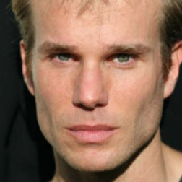
James Marshall
Movies
- A Few Good Men
- Gladiator
- Cadence

TV
- Twin Peaks
Web:
- www.james-marshall.net
- www.musicmanjimmy.com
Music
- Le Ciel
Departure of Toxins and Flu, The Arrival of Healing

A Real-life Matter of Life or Death

In his own words, the events of James Marshall’s struggle with modern-day medicine and his will to live.

“First I’m a spiritual actor, composer and performer. Such was not always my path. I had always wanted to be a part of the Hollywood scene and I was finally reaching the peak of my career. I had a role on the television show, Twin Peaks, and was cast in numerous roles in films such as Cadence, starring Martin Sheen and Charlie Sheen, Gladiator, starring Cuba Gooding Jr., and A Few Good Men, starring Tom Cruise, Jack Nicholson, and Demi Moore. I thought this was the beginning of a wonderful career when all of a sudden; it had to be put on hold.

I thought my life would end after taking the advice of a conventional medical provider, and it almost did. The medicine that was prescribed to me destroyed my large intestine to the point where it had to be
removed. After nearly two years of being bed-ridden in a hospital room, I weighed less than 100 pounds and my lack of energy and bad health had ended my acting career.
Link to more info about James Marshall— https://tinyurl.com/52jehfmf

One fateful night, I was up late searching for an answer. I began to listen to the Coast-to-Coast radio show. George Nooray was interviewing a woman about a healing technique that she had been developing using sound frequencies, Sharry Edwards. After research was done on this theory, it was proven that sound could heal people; you only had to find the right frequency and match it to the person.

I took a chance and called her research center. After hearing my story, she agreed to help. She used her own computer software to analyze my voice and it created a report on my health status. This report indicated which vitamins and nutrients I needed to help my body heal itself. Then I was told which foods would provide this for me and which I should avoid. Along with this I was given sound frequencies that would supposedly help to heal me as well.

Sharry gave me a list of individualized frequencies which I recreated using my guitar. Not musical notes but frequencies that could be tuned. It didn’t sound exactly like music but it was incredibly pleasing to me. I spent long hours with the sounds. I began to feel more and more like my old self. Since then I’ve learned that our DNA is basically frequency and it can be set to music. Was I using music to speak to my DNA in a way that caused my body to heal itself?
I started to gain weight, and my energy returned. I spent hours with the sounds, and I began to feel like my old self.

I became so fascinated at my own progress using sound that my wife, Renee, and I began to study, in depth, these ancient techniques of sound healing that were being brought into the modern era. When I learned that all of this stemmed from this woman’s innate ability to hear and duplicate sounds that were unlike normal human abilities, I knew that I wanted to be part of brining this “other dimensional” talent of hers to the forefront of health and wellness. She was very open to my ideas.
I wanted to work on something significant, something timely, something useful to the public. We chose the threat of the pandemic swine flu. She decoded the genetic make-up of the different strains of swine flu (as she had done for so many other pathogens) and using extrapolations from her previous research she came up with the frequency biomarkers for the swine flu; and was also able to mathematically determine the frequency-based antidotes.
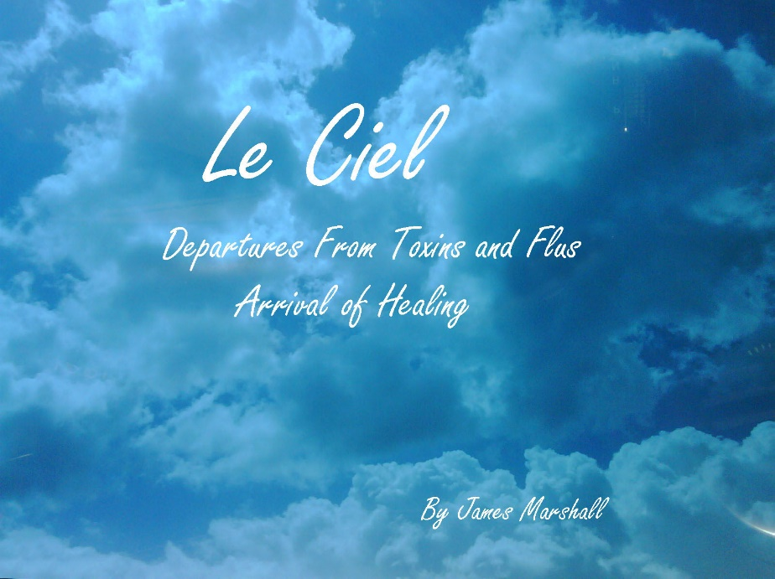
When I received the set of frequencies from her research lab, I was perplexed. These were not notes that one would play together harmonically. I could not see a way that these notes could be combined into a pleasing musical piece. But I believed in the magic of what she had done for me. I had to give it a try. To my surprise, the notes went together creating an unusual, yet aesthetic, combination of notes and tones. The first release was not meditative, relaxing music nor was it supposed to be. It was designed as a pathogen-killing set of frequencies. My wife and I, and others have found relief from colds, sinus irritations and sore throat symptoms. In real life, the frequencies were experimentally used to reverse diagnosed swine flu symptoms that were resistant to Tamiflu.
The second release contains the original eight-minute Swine Flu (Le Ciel (The Sky) frequency set but has been combined with relaxing meditation sounds. The result is a 30-minute sound journey, called Sines of Life: Arrival of Healing that is designed to relax the body into a state of self-healing.

Can these results be trusted? Many years of research substantiate the ability of music and sound to support optimal human form and function. What more can you ask? Do the techniques conform to the standards of conventional medical practice? No, but you cannot argue with the results. How does it work? I don’t think any of us can answer that yet. We only know that it does and that the public has a right to know about it.

In my case, standard medical practice had nothing to offer. I was told to go home and die. I believe that frequency-based biomarkers can be translated into sound and music, and hold the potential to change the face of medicine. This is too new, too innovative, too “out there” for people to wrap their heads around, but I’m living proof that it is real. It can potentially help thousands of people who have been left with no conventional options.

------------
This column strives to bring you information concerning the frequencies bombarding our planet each day in the hope of explaining how frequencies outside our solar system can impact health.

Each cell can renew itself or morph into something else if provided the correct frequency and energy.

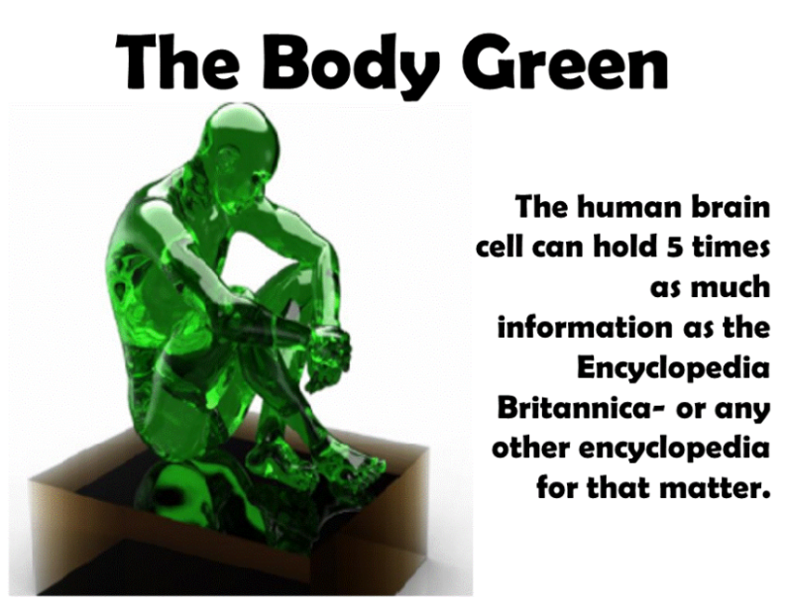

Frequencies associated with April 28 – May 4

METABOLIC MAGIC

Joint inflammation will be felt over the next few days. Glucosamine and docosahexaenoic acid (DHA) – both available at your local health food store - may be helpful.

Time for some liver pampering as liver enzymes come into stress. There are some great herbal liver cleanses described online; love your liver for great enzyme, hormone, and cholesterol health.

Chlamydia pneumonia (attacks the heart sac) and Epstein Barr (chronic fatigue virus associated with the liver) continue to plague our energy systems. It has been reported that Nutribiotic grapefruit extract doesn’t allow pathogens to attach to your cells when they attempt to set up housekeeping; it can help with pathogenic threats year ‘round.

Disease genes activated now includes colon cancer and Diabetes Insipidus.

Nutrient in stress: Magnesium (diabetes associated), B5 co-factors (help support energy metabolism and muscle biochemistry). B5 is also associated with tremors and the use of dopamine. L-dopa will be in stress by the end of the week.

Muscles in stress: gluteus medius and minimus (hip-butt muscles) and the trapezius (upper back muscles), finger flexors, Hamstrings and Levator (shoulder). By the end of the week the big toe and a jaw muscle, the Masseter will begin to rise.

Sometimes you can determine how in-tune you are with the Universe when you begin to experience these muscle responses before they come into full influence.

Foreknowledge of what frequency influences are on the way makes it appear that you are magical because you always know what stressors are about to occur.

Watch out for Vitamin D deficiencies and thyroid stress combined for the coming weeks.

May 5-11

Fatty Acids, particularly linoleic acid, are essential to utilizing the amino acid, Carnitine. Carnitine, in turn, is essential for the body to manage weight issues. BioAcoustically speaking people who cannot utilize Carnitine or those with high carnitine, find it hard to GAIN weight.

In addition to the frequency-based issue with Linoleic acid, the gene responsible for adrenal-based obesity is active for the next week or so. You may find difficulty in losing weight, especially with troublesome water weight, and feel sluggish and swollen.

Muscles in stress are all digit related; fingers and toes may be taking the brunt of this temporary water weight gain. Muscles related to eye focus are also in stress; you may find it more difficult to focus and keep focus without some blurring.

The management of calcium comes into stress on Monday. Cortisol disturbs calcium utilization. Those with cortisol issues may find it especially troublesome with possible calcium-related issues, muscle cramps, sleep disturbances, nerves on edge. Calcium is instrumental in protecting the body against cancer.

Calcitonin, a calcium regulating biochemical comes into play mid-week. Remember that calcitonin is a major player in the control of cancer food, 5-HETE. Thyrocalcitonin, aka, calcitonin, a calcium regulator of the parathyroid gland comes into play at mid-week though the weekend.

Tooth plaque continues to be an issue as nanobacteria are still active. The literature reports that tooth plaque may be an indicator of heart sac disruption. If you are having trouble walking up stairs or you are experiencing exertion stress that you didn’t notice before; this may be an issue. Nanobacteria is a disturbance of calcium metabolism.

Mother Nature indicates that spring is the time for renewal and growth. The same is true for humans as reproduction hormones peak this week in an attempt to prepare the body for new life.

Brain-derived neurotropic factor stirs at the end of the week making this a time for renewal of cells and nerves of the body and brain. Time for some brain games to take advantage of creating new pathways.

May 12-18

Fatty Acids, particularly linoleic acid, are essential to utilizing the amino acid, Carnitine. Carnitine, in turn, is essential for the body to manage weight issues. BioAcoustically speaking people who could not utilize Carnitine or those with high carnitine, found it hard to GAIN weight.
In addition to the frequency-based issue with Linoleic acid, the gene responsible for adrenal based obesity is active for the next week or so. You may find it difficult to lose weight; especially with the troublesome water weight. You may feel sluggish and swollen.

Muscles in stress are all digit related; fingers and toes may be taking the brunt of this temporary water weight gain. Muscles related to eye focus are also in stress; you may fight it more difficult to focus and keep focus without some blurring.

The management of calcium comes into stress on Monday. Cortisol disturbs calcium utilization. Those with cortisol issues may find it especially troublesome with possible calcium related issues; muscles cramps, sleep disturbances, nerves on edge. Calcium is instrumental in protecting the body against cancer.

Calcitonin, a calcium regulating, biochemical comes into play mid-week. Remember that calcitonin is a major player in the control of cancer food, 5-HETE. Thyrocalcitonin, aka, calcitonin, is a calcium regulator of the parathyroid gland comes into play at mid-week though the weekend.

Tooth plaque continues to be an issue as nanobacteria is still active. The literature reports that tooth plaque may be an indicator of heart sac disruption. If you are having trouble walking up stairs or exertion stress that you didn’t notice before; this may be an issue. Nanobacteria is a disturbance of calcium metabolism.

Mother Nature indicates that spring is the time for renewal and growth. The same is true for humans as reproduction hormones peak this week in an attempt prepare the body for new life.

Brain derived neurotropic factor stirs at the end of the week making this a time for renewal of cells and nerves of the body and brain. Time for some brain games to take advantage of creating new pathways while you can.

May 19-25

Frequencies for Gardasil vaccines become active this week and remain so through the end of the month. Gardasil is a series of injections provided, mainly to youngsters, as prevention to cancer; and cervical warts contracted through sexual interactions. California has passed a law allowing girls as young as 12 to submit to a three-part series of separate injections without parental permission even though serious adverse effects (including deaths) have been reported in large numbers; consequences that would fall on the shoulders of uninformed parents.

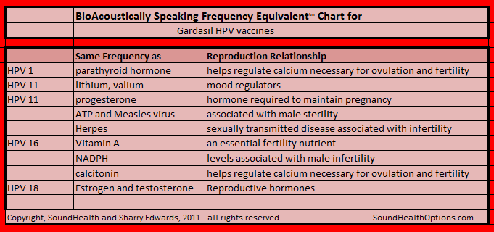
Four strains of HPV (Human papilloma virus), contained in the CDC recommended Gardasil vaccination database, are being pushed on the American population; HPV 1, 11(x2), 16 and 18. Are these vaccines safe or do they pose a greater threat that has not yet been exposed? This possibility was BioAcoustically explored, and the information is compiled in the Frequency Equivalent™ chart below.

A Quote from Dr. Diane Harper, lead researcher concerning Gardasil says that 70% of all HPV infections resolve themselves with a year, and within two years that percentage climbs to 90%. Dr. Harper also states that Gardasil would do little to prevent cancer and she does not recommend Gardasil or Cervarix (a similar vaccine) to anyone younger than 15.
An additional statement by Harper in 2013 is that parents should be warned of the harmful effects of the Gardasil vaccinations. She quotes so far that “15,037 girls have reported adverse side effects from Gardasil alone to the Vaccine Adverse Event Reporting System (V.A.E.R.S.), and this number only reflects parents who underwent the hurdles required for reporting adverse reactions. At the time of writing, 44 girls are officially known to have died from these vaccines. The reported side effects include Guillian Barré Syndrome (paralysis lasting for years, or permanently — sometimes eventually causing suffocation), lupus, seizures, blood clots, and brain inflammation. Parents are usually not made aware of these risks.”

Since research does not support this campaign of Gardasil vaccinations, what else could be the motive to require such threatening measures? The Gardasil movement in Texas brought some of the underlying motivation to the surface. Former Texas Governor Rick Perry mandated Gardasil for the State of Texas, but public outcry shut down the program. Later it was discovered that Perry and his campaign received over $300,000 from the pharmaceutical companies that were in support of mandated, massive Gardasil crusades but there seems to be an even more sinister reason.

Frequency medicine is making a comeback as part of our conventional medical protocols. Gardasil components like any other medication are based on the influence of the compounds it contains. An evaluation of Gardasil components revealed that frequency biomarkers contained within the four available vaccines may have been produced to influence fertility and reproduction.

May 26 – June 1

Strongly manifesting for the next few days: Frequencies associated with Chronic Lymphocytic Leukemia (CLL) – cancer of the white blood cells which are responsible for fighting infection by producing antibodies to protect the body. CLL creates a compromised immune system in which the body is weakened to the point that it cannot fight stress, pathogen invasion and disease.

Muscles in stress: Interossei of fingers which provide flexibility to the hands and fingers are moving out of range allowing arthritis-like symptoms to let up a bit.

Activated Nutrients: Zeaxanthin – an important bioflavonoid helps rid the body of free radicals. The vitamin most influenced is Lutein – A form of Vitamin A for eyes. If this is an issue for you, you may find that your eyes are a bit slower to focus – lots of allergies may be contributing to this factor for people.

Stearic acid is a biochemical found in cosmetics. The body uses it to insulate nerves; it is also associated with cholesterol management.
The toxin active now is Hexachlorobenzene – It was used on marijuana as a pesticide until they found out that the residue causes mummified hands – then whole-body atrophy.

Morphine – A medication - we don’t often report on medications but this may be an important one – because it is often left over from surgeries so you may feel a bit groggy or out of it for a bit as it activates and moves out of the body. Medication frequencies of Valium/Diazepam are being activated at the end of the week. Both are used as medications to treat anxiety, alcohol withdrawal, muscle spasms, panic attacks are activated. Watch for side effects. Morphine, a powerful pain killer is also stimulated until mid-week.

Several forms of papilloma virus (HPV) – which causes common warts on hands, feet and mucous membranes of the oral, anal and genital cavities - are in stress over the next few weeks. HPV (Gardasil/Cervarix) immunizations were developed allegedly to prevent HPV outbreaks.

BioAcoustically Speaking, the chart below shows that the frequencies of Gardasil and Cervarix correlate with issues of fertility and conception. This will potentially cause issues with reproduction.

Links:
http://video.foxnews.com/v/1164906002001/controversial-vaccine-bill
http://www.activistpost.com/2011/09/3-girls-dead-others-hospitalized-after.html
http://www.cbsnews.com/stories/2009/08/19/cbsnews_investigates/main5253431.shtml
http://www.naturalnews.com/032330_vaccines_iPod.html
http://www.afullcup.com/forums/cvs-101/260374-flu-shot-100-coupon-book.html
http://naturalsociety.com/advisory-panel-urges-cdc-to-push-gardasil-on-young-boys/
http://articles.mercola.com/sites/articles/archive/2011/10/28/cdc-director-arrested-for-child-molestation--bestiality.aspx?e_cid=20111028_DNL_art_1
http://www.newsy.com/videos/perry-s-papilloma-payoff/

